Co-Designing Better Multi-Hazard Early Warning Systems with Community Feedback
Final Report
Written by IRI/NCDP, Columbia University
UN World Food Programme Belize, March 2026

Table of Contents
Executive Summary 2
Methodology 3
Approach 3
Timeline 4
Links to Key Resources 4
Stakeholder Priorities 4
NMS Recommendations 4
Stakeholder Workshop Participants 6
Climate Impact Events 6
Climate Impact Timing 7
Hazard Maps and Analysis Tools 8
Drought (Agricultural) 8
Orange Walk 10
Toledo 12
Station Analysis 13
Drought (Hydrological) 14
Orange Walk 15
Toledo 15
Station Analysis 16
Excess Rain and Flood 17
Orange Walk 18
Toledo 19
Station Analysis 19
Heat 20
Orange Walk 22
Toledo 24
Station Analysis 25
Storms 27
Orange Walk 28
Toledo 29
Wildfires 29
Orange Walk 31
Toledo 32
Best Practices for Measurement and Forecasting 33
Early Warning System Design 33
Drought (Agricultural) 33
Drought (Hydrological) 33
Excess Rain 34
Heat 34
Storms 35
Wildfires 35
Supporting Literature 36
Key Early Warning Messages 36
Forecast-based actions 36
Forecast / climate information needed 38
Questions for the community 40
Potential Next Steps 41

Executive Summary
This document presents a comprehensive and detailed report on measuring, mapping and forecasting climate impacts in Belize. The primary objective of this report is to inform impact-based multi-hazard early warning systems (MHEWS) for the Belize NMS. To that end, this report focuses on methods for the historical analysis of climate impacts, with an emphasis on how to relate them to observed and forecasted climate hazard data. It is not meant to be an exhaustive analysis of all risks, but rather a practical guide to a system and process that the NMS can adapt to a variety of MHEWS contexts and users.

The structure of this report is as follows: First, we present the methodology and key activities conducted. Second, we present the results of the multi-hazard mapping analysis, including the tools for NMS that we developed. Third, we present some suggested best practices for measuring, forecasting, and communicating risk about each climate hazard. We conclude with some discussion of next steps and scope for future work based on stakeholder feedback.

This report follows a series of workshops and consultations with Belize NMS, WFP, and government and NGO stakeholders. Throughout the report, their feedback and how it was incorporated into the analysis is noted.

This project resulted in a set of co-designed maptools for analyzing historical climate hazards and impacts, monitoring forecasts, and communicating probable impacts, following a multi-hazard impact-based forecasting approach. At each step, the datasets and metrics used, historical impacts analyzed, and thresholds for action chosen reflect input from stakeholder consultation. All of the code and materials used for this project are available in the accompanying Github repository, and have been shared with NMS.

Potential next steps for the project would include more community-level surveys on climate impacts, scaling up this approach to other countries in the Caribbean, and going deeper on analysis for other regions of Belize. Stakeholders from the Red Cross and CCCCC have expressed interest in participating in these scale-up activities.

Methodology

Approach

Our approach to improving multi-hazard early warning systems covered the following steps:

1. Identify relevant use cases: Identify priority climate hazards and timescales that would benefit from community validation and local knowledge integration, focusing on hazards where community input can fill critical data gaps or validate technical assessments.

2. Historical risk event validation: Conduct stakeholder focus groups using IRI's standardized methodology to elicit community-identified historical disaster years. This information is critical for retrospective evaluation of climate risk assessment decision rules, ensuring that forecast triggers align with community experiences of actual disaster events.

3. Fill data gaps: Frame community information collection as a means to fill gaps in existing data sources, particularly where:
- Official monitoring networks are sparse
- Historical records are incomplete (e.g., EMDAT data limitations for Belize)
- Local impacts and vulnerabilities are not captured in national datasets
- Community-specific adaptation strategies and capacities need documentation

4. Validate metrics and decision rules: Validate risk metrics, hazard indicators, and forecast decision rules through community engagement:
- Compare technical assessments against local experiences and observations
- Validate that climate risk assessment triggers would have captured known historical disaster events
- Ensure decision rules align with community-identified worst years for each hazard
- Use community input to refine trigger thresholds and action protocols

5. Forecast communication: Drawing on the results of the above, align community-based early warning triggers with forecast information on multiple timescales:
- Identify areas with greatest hazard, exposure and vulnerability to impact for a given forecast,
- Identify key warning messages for communicating risk and forecast uncertainty

Through this process, we focus on using tools and data that are open source and freely available to the NMS. This includes Kobo for community data collection, Google Earth Engine for climate hazard, exposure, and vulnerability data analysis, and Github for code and documentation management and version control.

Timeline
- October 2025:
  - Project inception
- November 2025:
  - Data inventory; initial stakeholder priority consultation
- December 2025:
  - Inception report and situational analysis report
- January 2026:
  - Hazard mapping development
- February 2026:
  - Risk and vulnerability report
- March 2026:
  - NMS technical training
  - Stakeholder workshop
  - Final report

Links to Key Resources
All of the reports, data and code used for this project are available via the following Github repositories:
- https://github.com/ccsfist/belize_earthengine (Earth Engine technical guide, and all code and technical report files, under “reports” and “scripts)
- https://github.com/ccsfist/belize_earlywarning (NMS workshop materials)
- https://github.com/ccsfist/belize_stakeholders (stakeholder workshop material)

Stakeholder Priorities

NMS Recommendations

The following table summarizes NMS’s technical recommendations for hazard measurement, based on discussion during the technical training:

Hazard | Geographic priority | Worst hazard years | Key times of year | Suggested metrics | Forecast information | Impact information | Other agencies to consult
Drought | Northern districts | 2004,2014,2015,2019 | May (onset), JJA (growing season) | dry spell length and onset timing (may); cumulative rainfall (jja) | Yes - NMS weather forecast and PyCPT seasonal forecast | 2004,2015,2016,2019 | Agriculture (seasonal), Energy (seasonal), Water (seasonal), Health (weather - dehydration)
Flood / Excess Rainfall | Southern (flash floods, riverine), Belize City (flash floods, storm surge, poor drainage) | 2020, 2014, 2008, 2016, 2024 | Oct, November, hurricane season | Rainy season maximum, days over 50mm or 84mm, 3-4 day long rain runs | 24-hour rainfall forecast; look at key weather-scale indicators (tropical desk); CAFFGS flash flood data system | 2020, 2014, 2008, 2016, 2024 - but aggressive start to season matters for farmers | NEMO, Red Cross, Hydrology, Energy, Agriculture
Extreme Heat | Belmopan, central inland areas, northern | many of the years listed for drought, but also others; 2024, 2005, 1995, 1998, 1984, 2010, 1973, 2013 | Mar-Apr-May (2013 september, an exception). getting worse during the wet season as well | 95th percentile of climatology for the whole record. 90th for "hot day". heat wave is min 2 consecutive days | Daytime temp used currently, but day-night gradient also important. Weather timescale forecasts of daily temp. Also, seasonal heat wave forecasts from CIMH, heat hazard 2-week forecast from NOAA | 2024 worst in recent memory. otherwise varies by sector / area. 28 degree threshold for livestock impacts (inland). 30 deg threshold for health. | ministry of health uses forecasts to plan hospital ER capacity. also, dengue incidence. combined hazard of heat and fire outbreak matters as in 2024.
Storms | South, Central, and north (Corozal area) | 2000, 2001, 2007, 2010, 2016, 2008, 2020, 2022 | Sept-Oct, but ranges as far as Aug-Nov | Wind speed (weather stations), NOAA storm tracks, satellite storm extent | NOAA, GFS, ECMWF | 2001, 2022 (hit San Ignacio and Belize City), 2000, 2010, 2016 - unusual paths are important. Personal accounts (need to understand exposure) | Red Cross, NEMO, Agriculture, Health - currently using NMS forecasts
Wildfires | Hattieville, Central inland, Southern | 2024, 2023, 2016, 2019, 2020 | Feb-May, but 2024 fire was in May-Jun | Rainy season onset, previous year's storm damages trees, soil moisture, wind speed, temperature | lightning risk, rainfall (seasonal and weather scale), temperature, CAFFG soil moisture | 2024 | Forestry, agriculture, health, energy, fire dept, environment, NEMO

Stakeholder Workshop Participants
The following sections show results of the stakeholder discussion. The stakeholder workshop included participants from the following organizations:

- WFP
- UNDP
- NMS
- Columbia University
- MPUEL
- Ministry of Blue Economy
- Ministry of Tourism
- Hydro Belize
- NCCO
- SIRDI
- NEMO
- Ministry of Environment
- TASA
- CZMAI
- MHD
- CCCC
- BWS
- BPA
- Red Cross
- BTL

Climate Impact Events
The following charts show the worst reported years for the impact of each hazard, based on feedback from the stakeholder consultation.

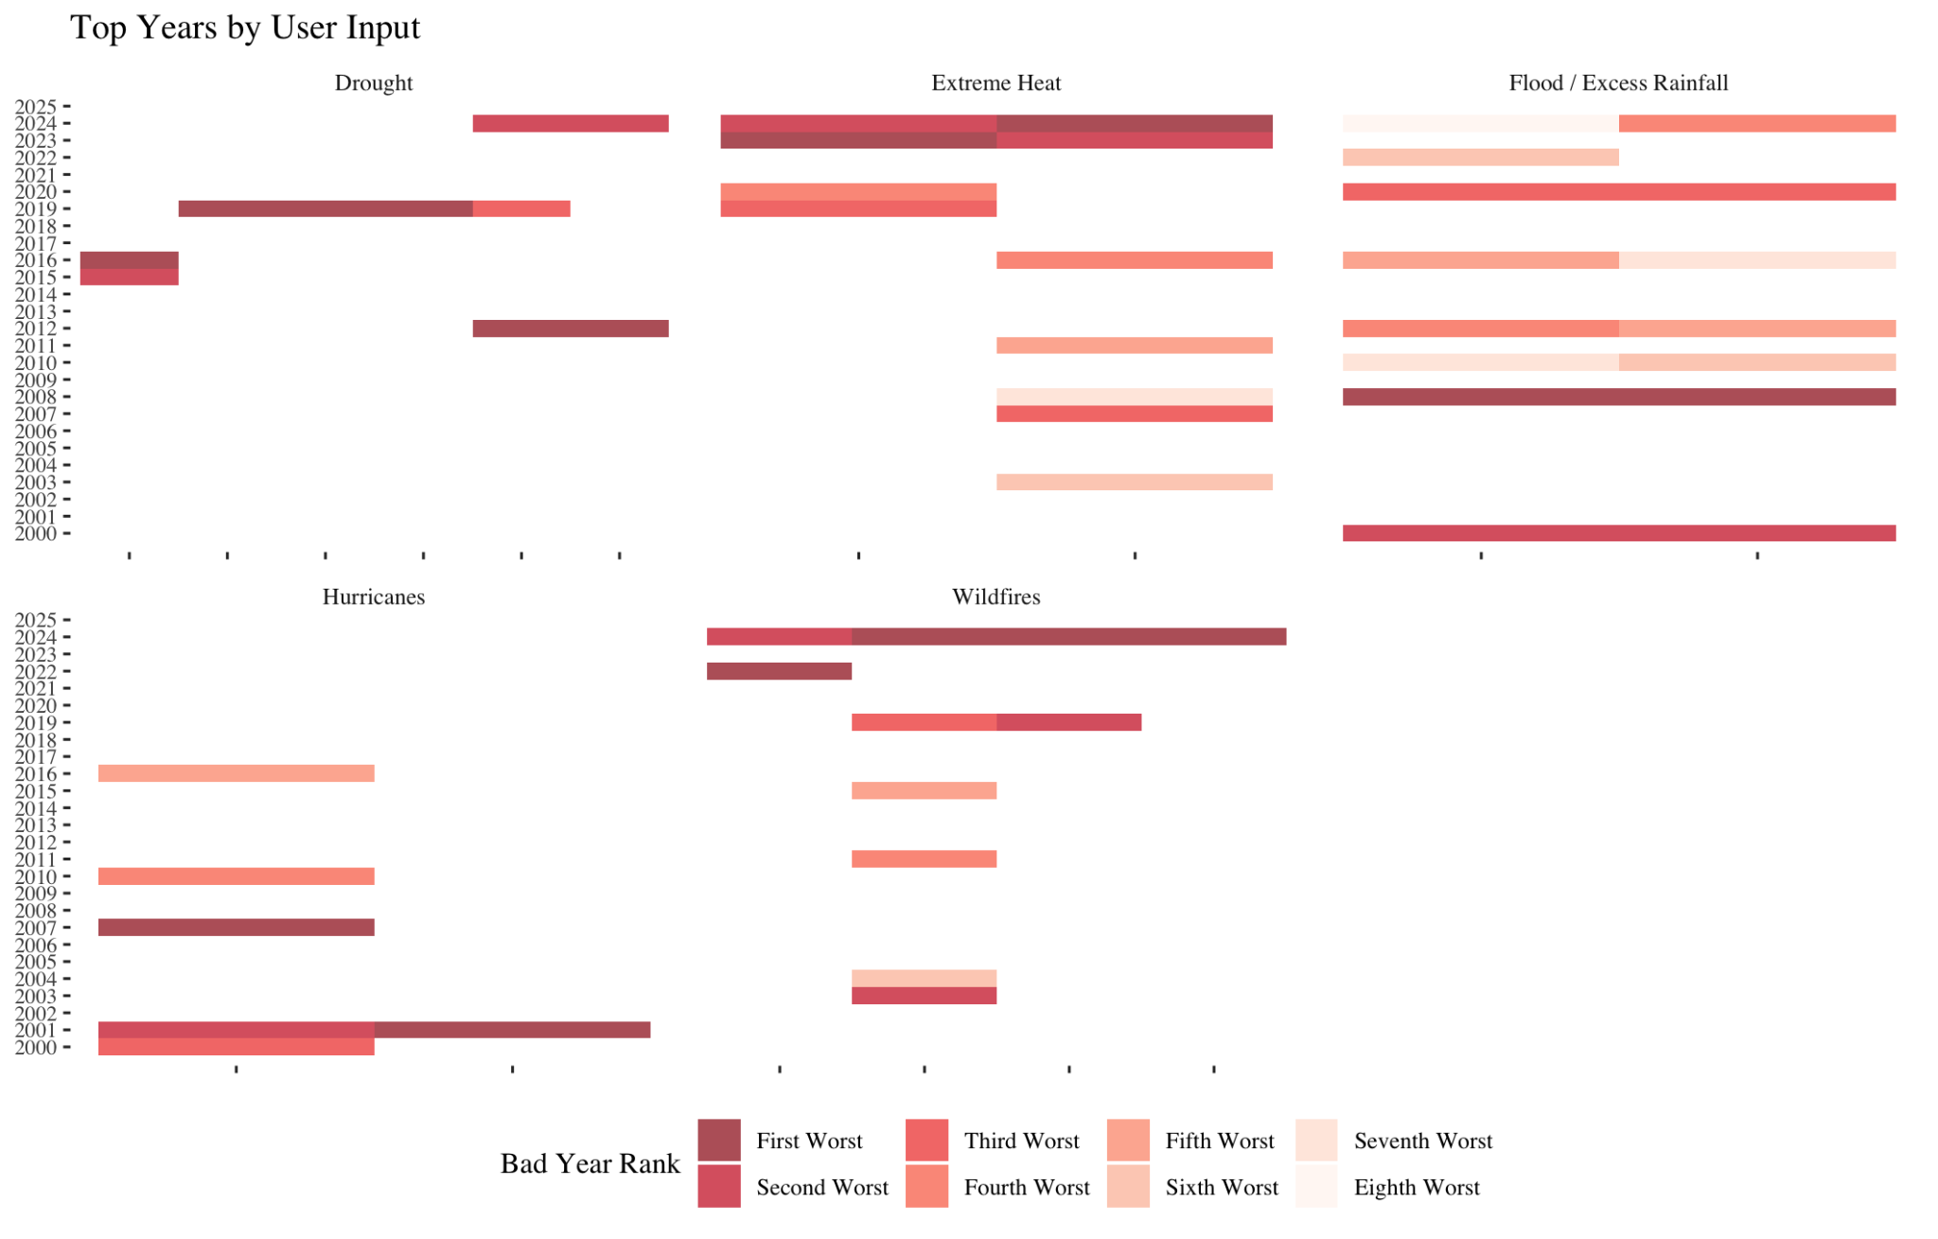

Climate Impact Timing
The following charts show the most critical times of year for the impact of each hazard, based on feedback from the stakeholder consultation.

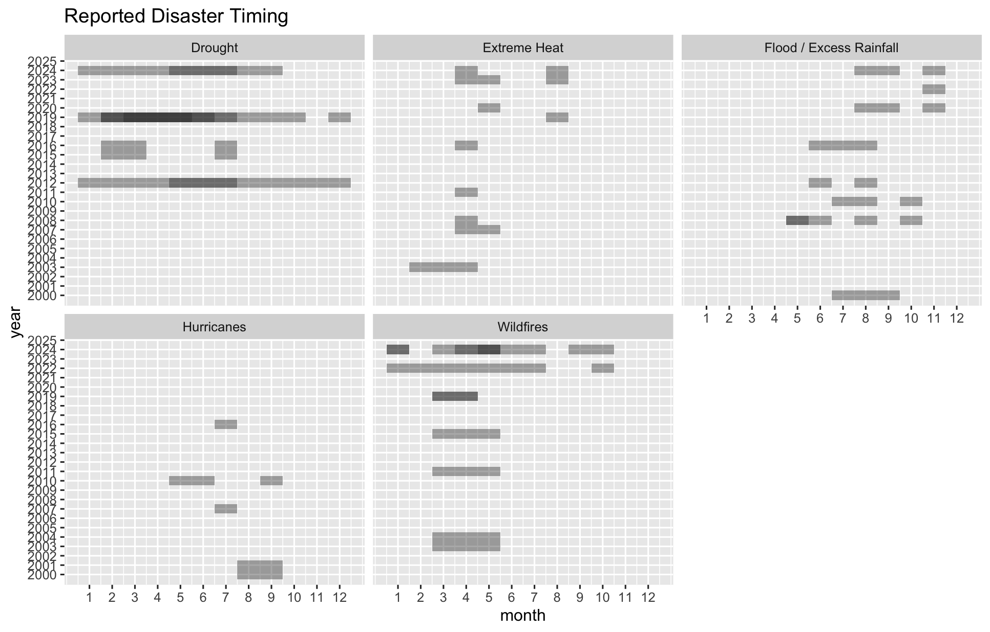

Hazard Maps and Analysis Tools
The following maps and tables show key takeaways from the hazard mapping analysis, with a focus on the Orange Walk and Toledo districts. Links to the interactive maptools and their code can be found at the end of the Methodology section above.

Drought (Agricultural)
https://ee-maxmauerman.projects.earthengine.app/view/belizedrought

Based on feedback from NMS and stakeholder agencies, the agriculture drought analysis uses the timing of rainy season onset (defined as the first 5-day period of the year with at least 25mm of cumulative rainfall) as its primary measure of hazard.

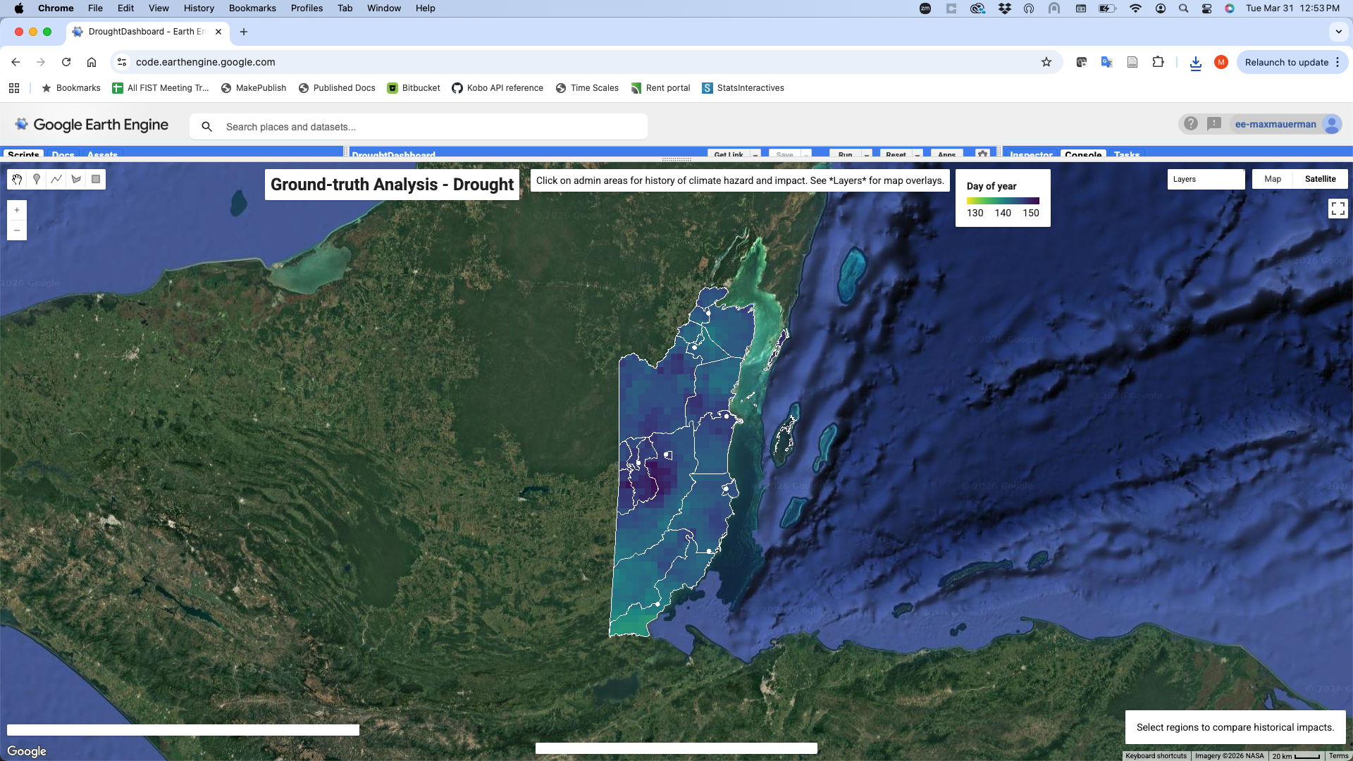



This map shows the average onset date over each part of Belize, 2000-present.

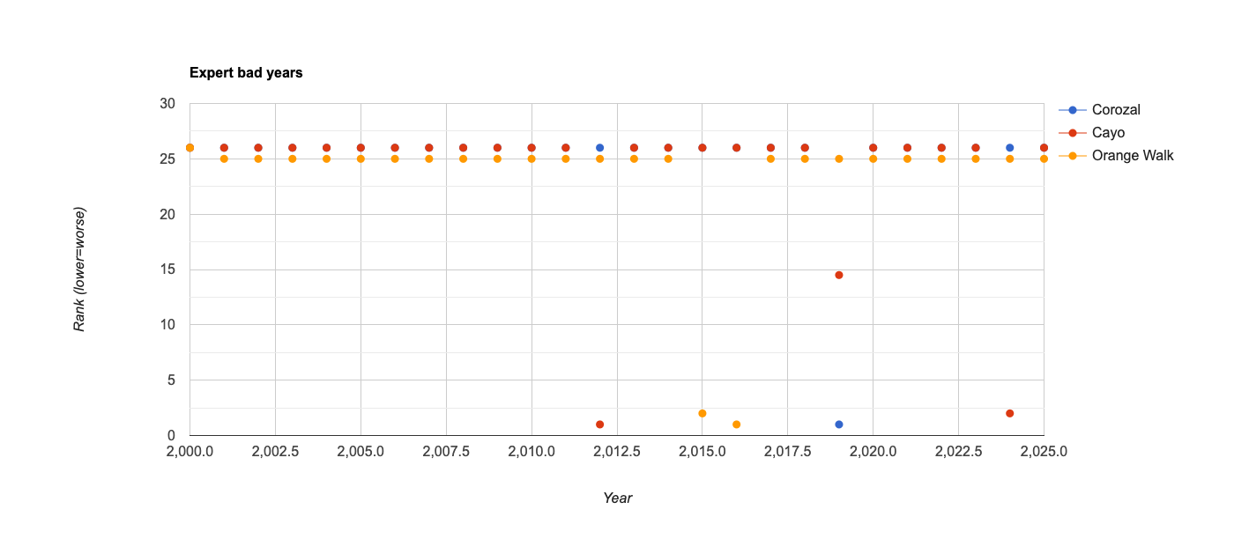
This plot shows the reported worst years for drought impact in Belize, based on stakeholder feedback.

Orange Walk
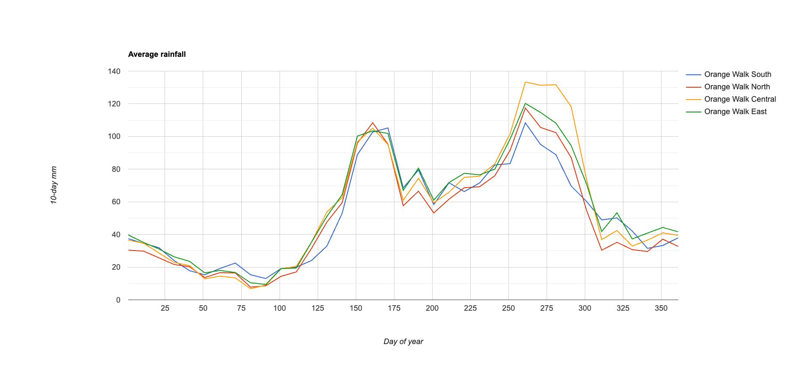
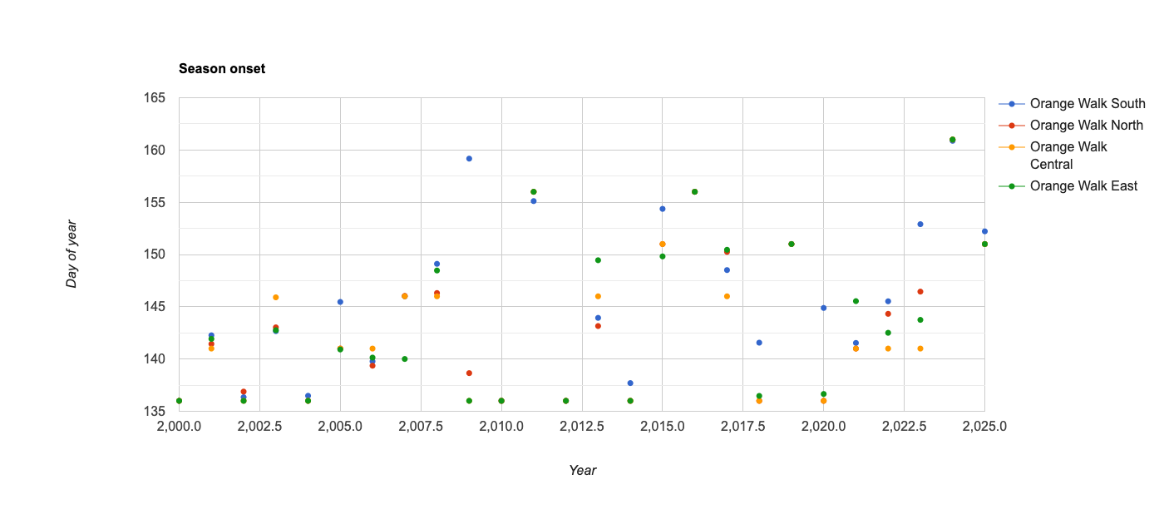

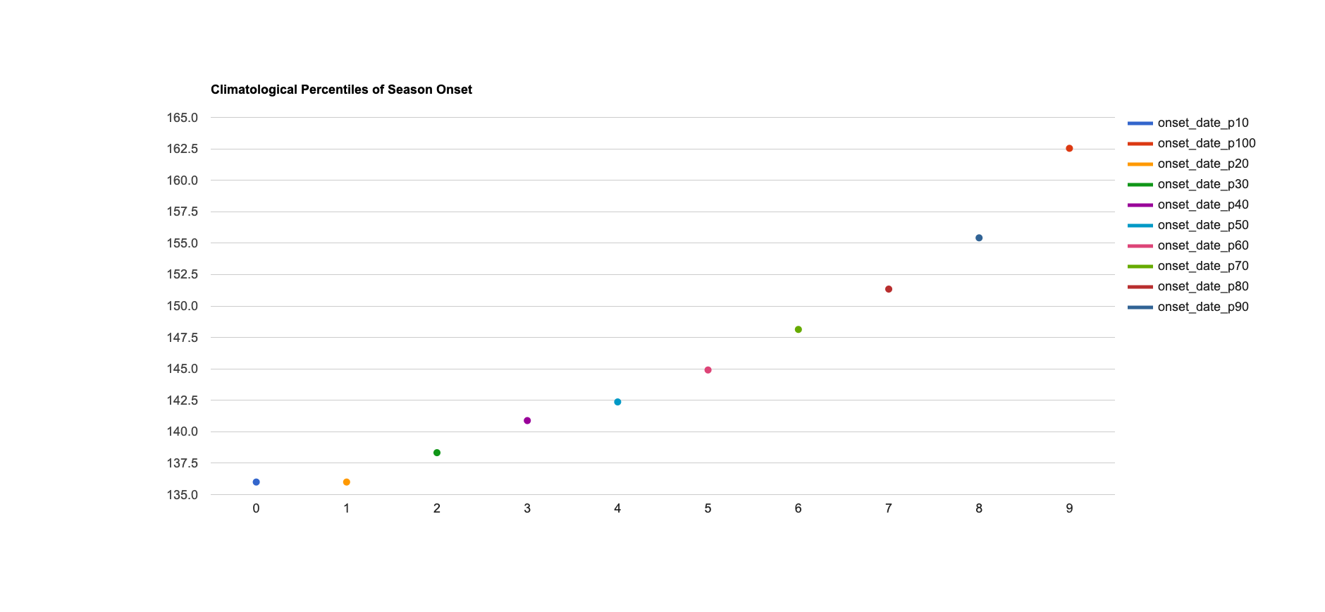
These plots show the rainfall climatology, historical onset dates, and percentiles of onset date for the constituencies of Orange Walk District. Some of the worst years in terms of late season onset were 2025, 2024, 2023, 2019, 2016, 2015, 2011 and 2009. All were at or above the 80th percentile of late onset. Of those years, 4 were mentioned as impactful droughts by stakeholders.

Toledo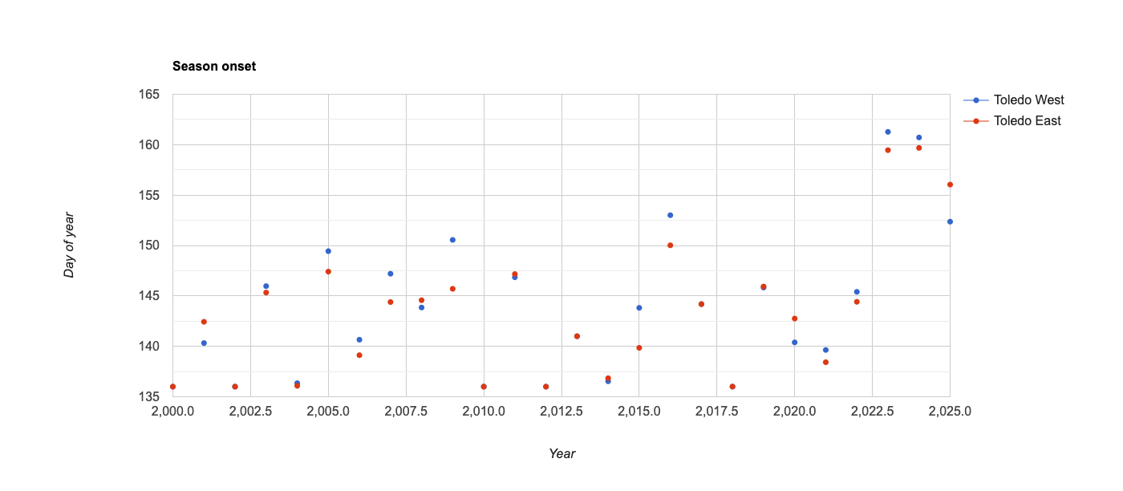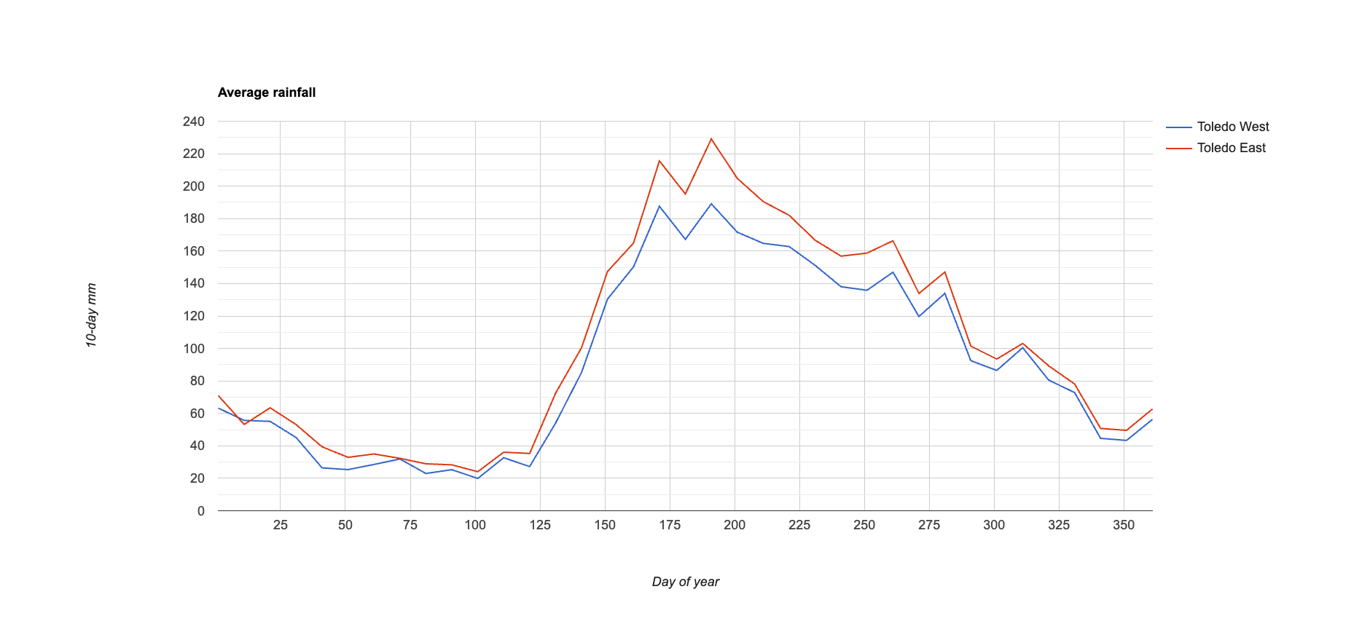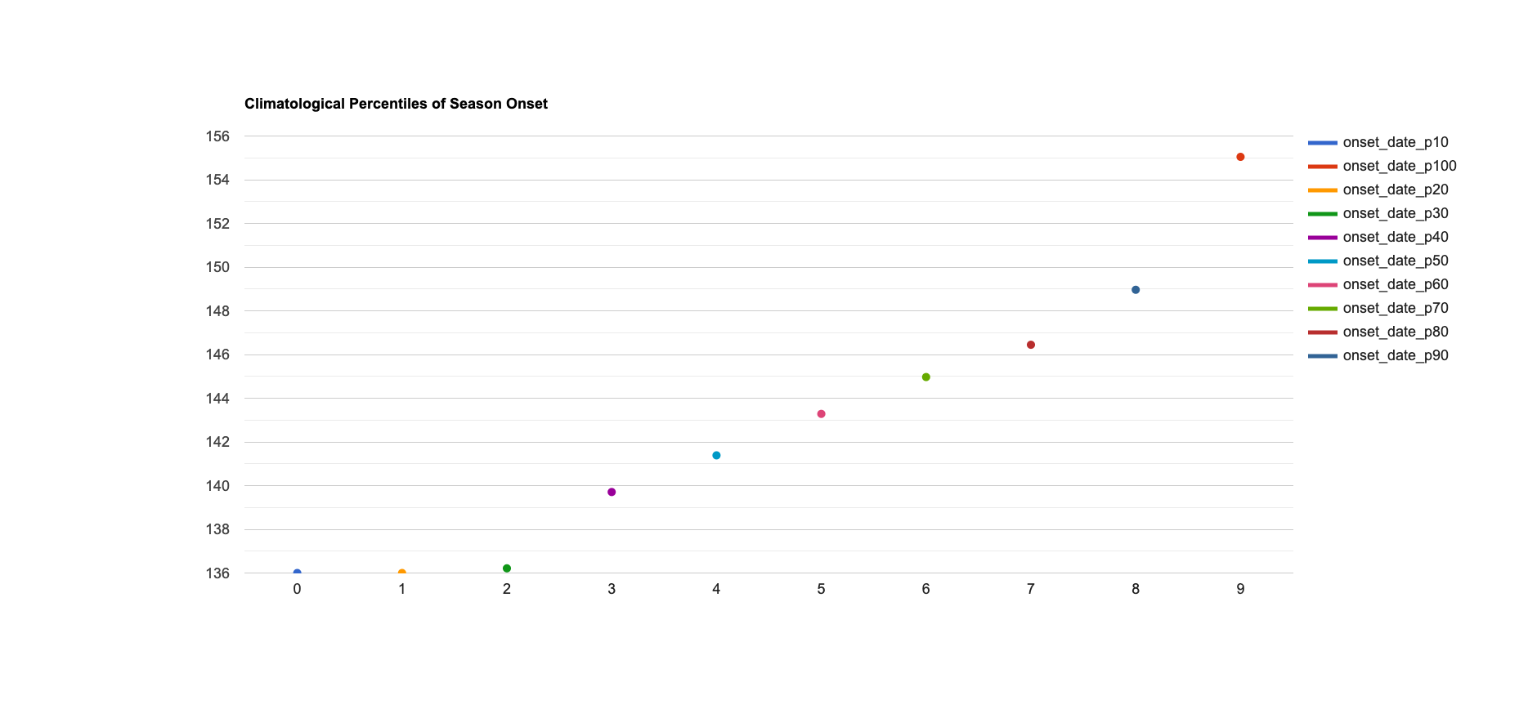
These plots show the rainfall climatology, historical onset dates, and percentiles of onset date for the constituencies of Toledo District. Some of the worst years in terms of late season onset were 2025, 2024, 2023, 2016, 2009 and 2005. All were at or above the 80th percentile of late onset. Of those years, 3 were mentioned as impactful droughts by stakeholders.

Station Analysis
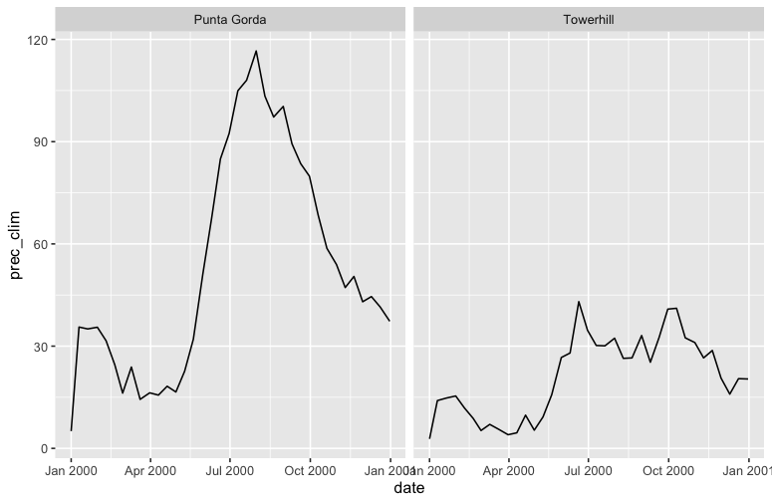

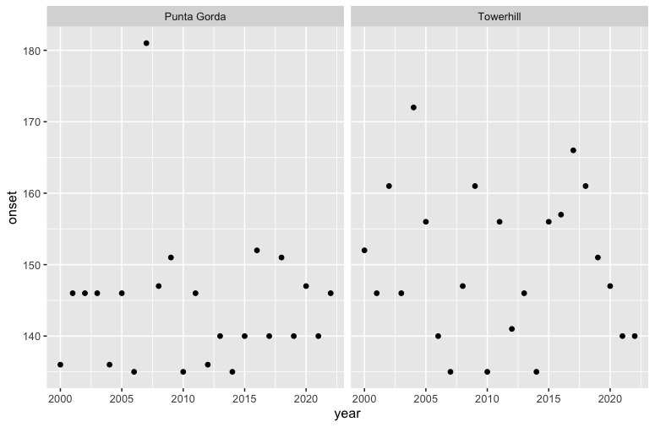

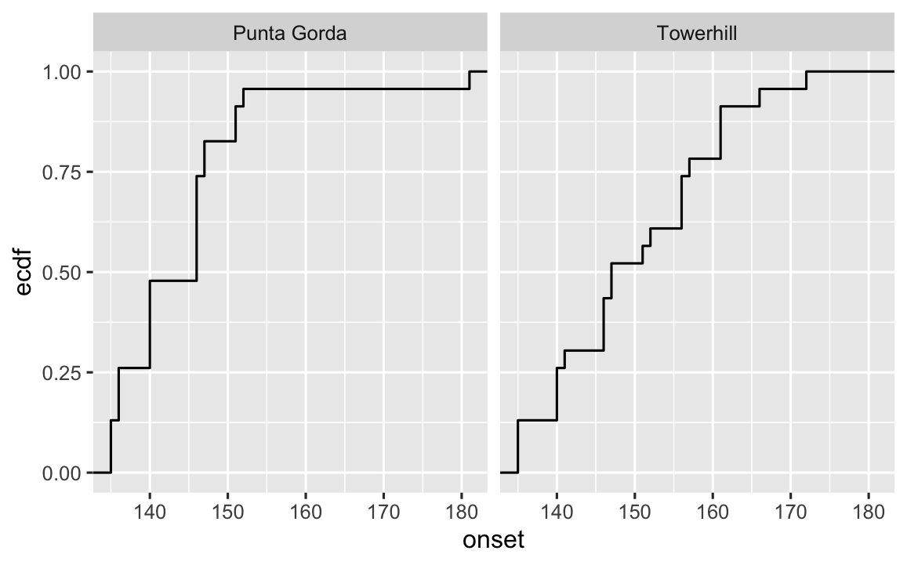
The above plots show the same analysis quantities, but computed with NMS weather station data instead of CHIRPS. The worst years and percentile thresholds are similar in both datasets.

Drought (Hydrological)
https://ee-maxmauerman.projects.earthengine.app/view/belizedrought

Based on feedback from NMS and stakeholder agencies, the hydrological drought analysis uses cumulative JJA rainfall as its primary hazard metric.

Orange Walk
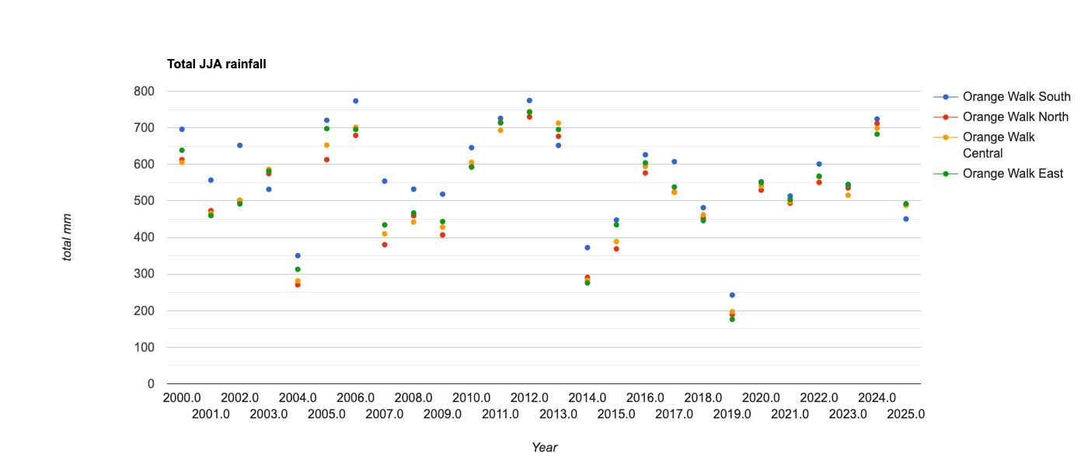
The worst years for cumulative JJA rainfall in Orange Walk include 2019, 2014, 2009, 2007 and 2004.

Toledo

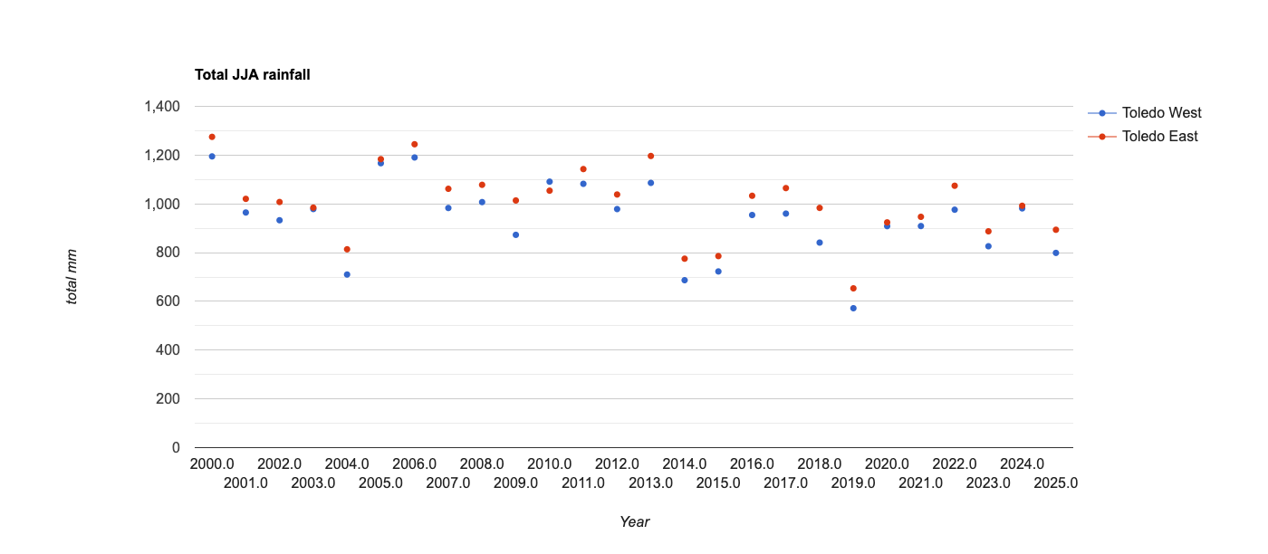
The worst years for cumulative JJA rainfall in Toledo include 2019, 2015, 2014, and 2004.

Station Analysis
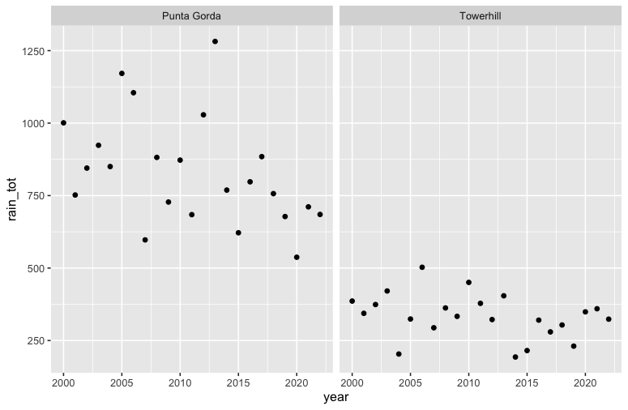
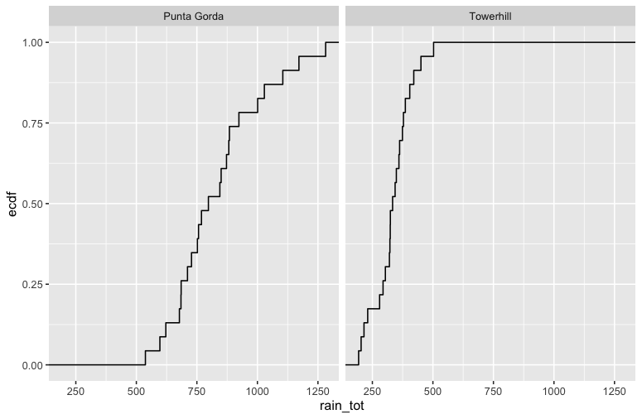

The above plots show the same analysis quantities, but computed with NMS weather station data instead of CHIRPS.

Excess Rain and Flood
https://ee-maxmauerman.projects.earthengine.app/view/belizeflood

Based on feedback from NMS and stakeholder agencies, the excess rainfall analysis uses the length of rainy spells (defined as the consecutive days with at least 100mm of daily rainfall) as its primary measure of hazard.

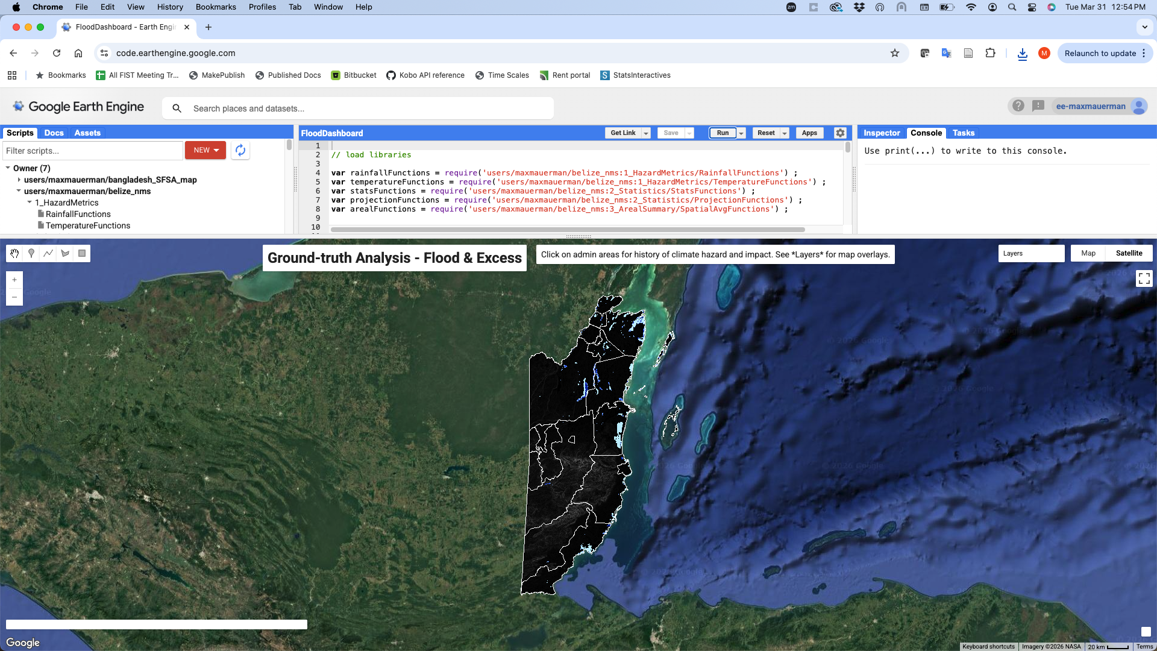

This plot shows the average inundated area over Belize based on the Global Flood Database dataset, 2000-present.

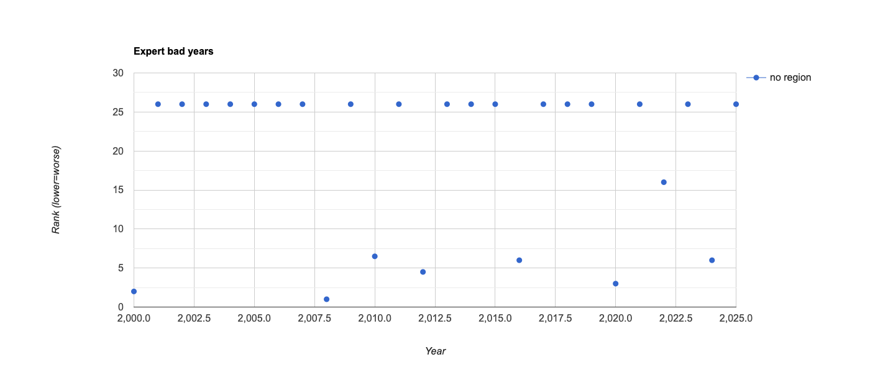
This plot shows the reported worst years for excess rainfall and flood impact in Belize, based on stakeholder feedback.

Orange Walk
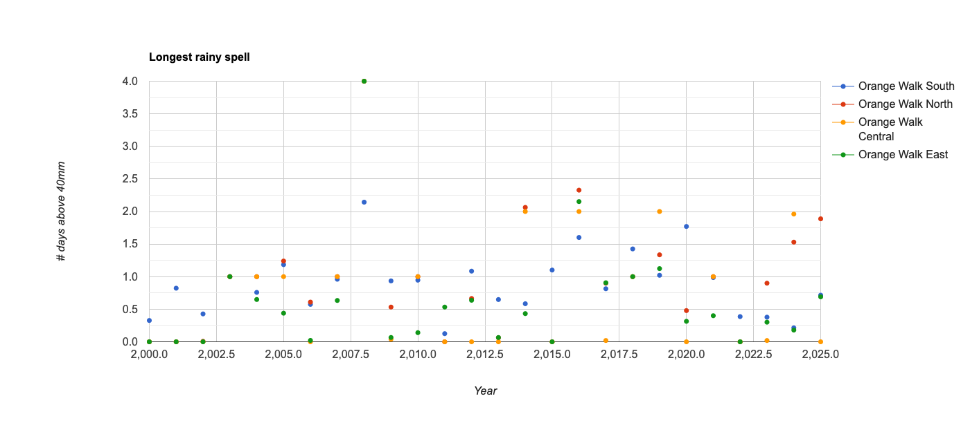
These plots shows the length of the longest rainy spell in each year for the constituencies of Orange Walk District. Some of the worst years in terms of excess rain were 2008, 2016, 2019, 2020, 2024 and 2025, although there is some variation between neighboring constituencies. Of those years, 4 were mentioned as impactful events by stakeholders.

Toledo
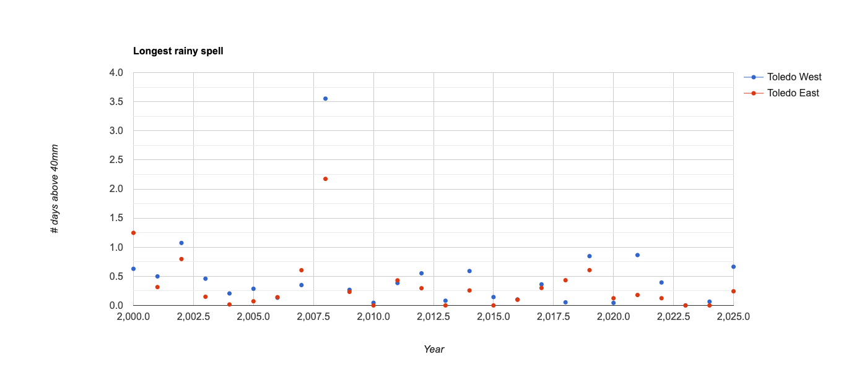

These plots shows the length of the longest rainy spell in each year for the constituencies of Toledo District. Some of the worst years in terms of excess rain were 2000, 2002, 2008, 2019, 2021 and 2025. Of those years, 3 were mentioned as impactful events by stakeholders.

Station Analysis

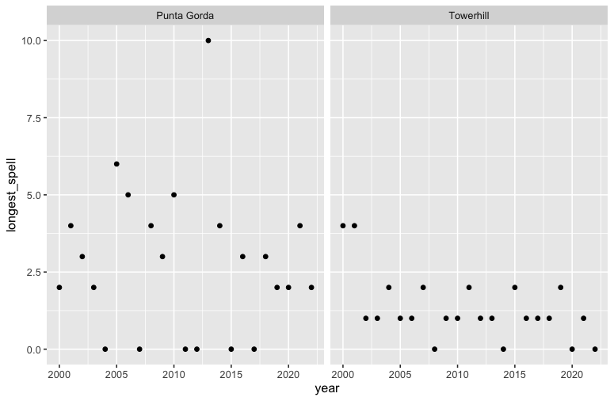
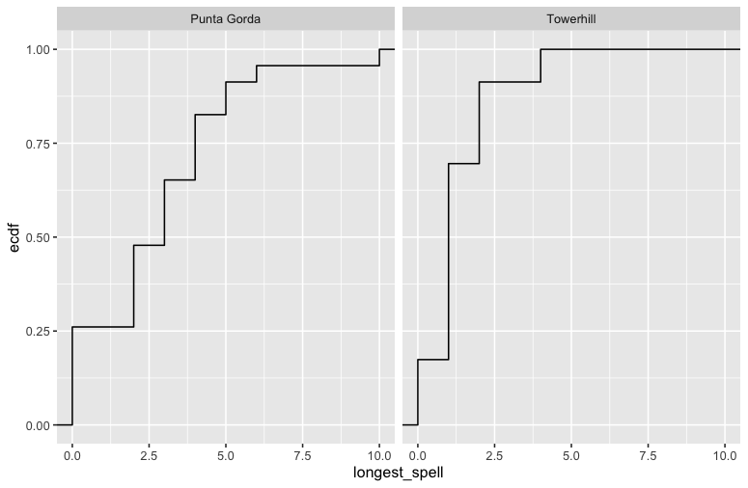
The above plots show the same analysis quantities, but computed with NMS weather station data instead of CHIRPS.

Heat
https://ee-maxmauerman.projects.earthengine.app/view/belizeheat

Based on feedback from NMS and stakeholder agencies, the extreme heat analysis uses the length of heat waves (defined as the consecutive days with at least 35c maximum temperature) as its primary measure of hazard.

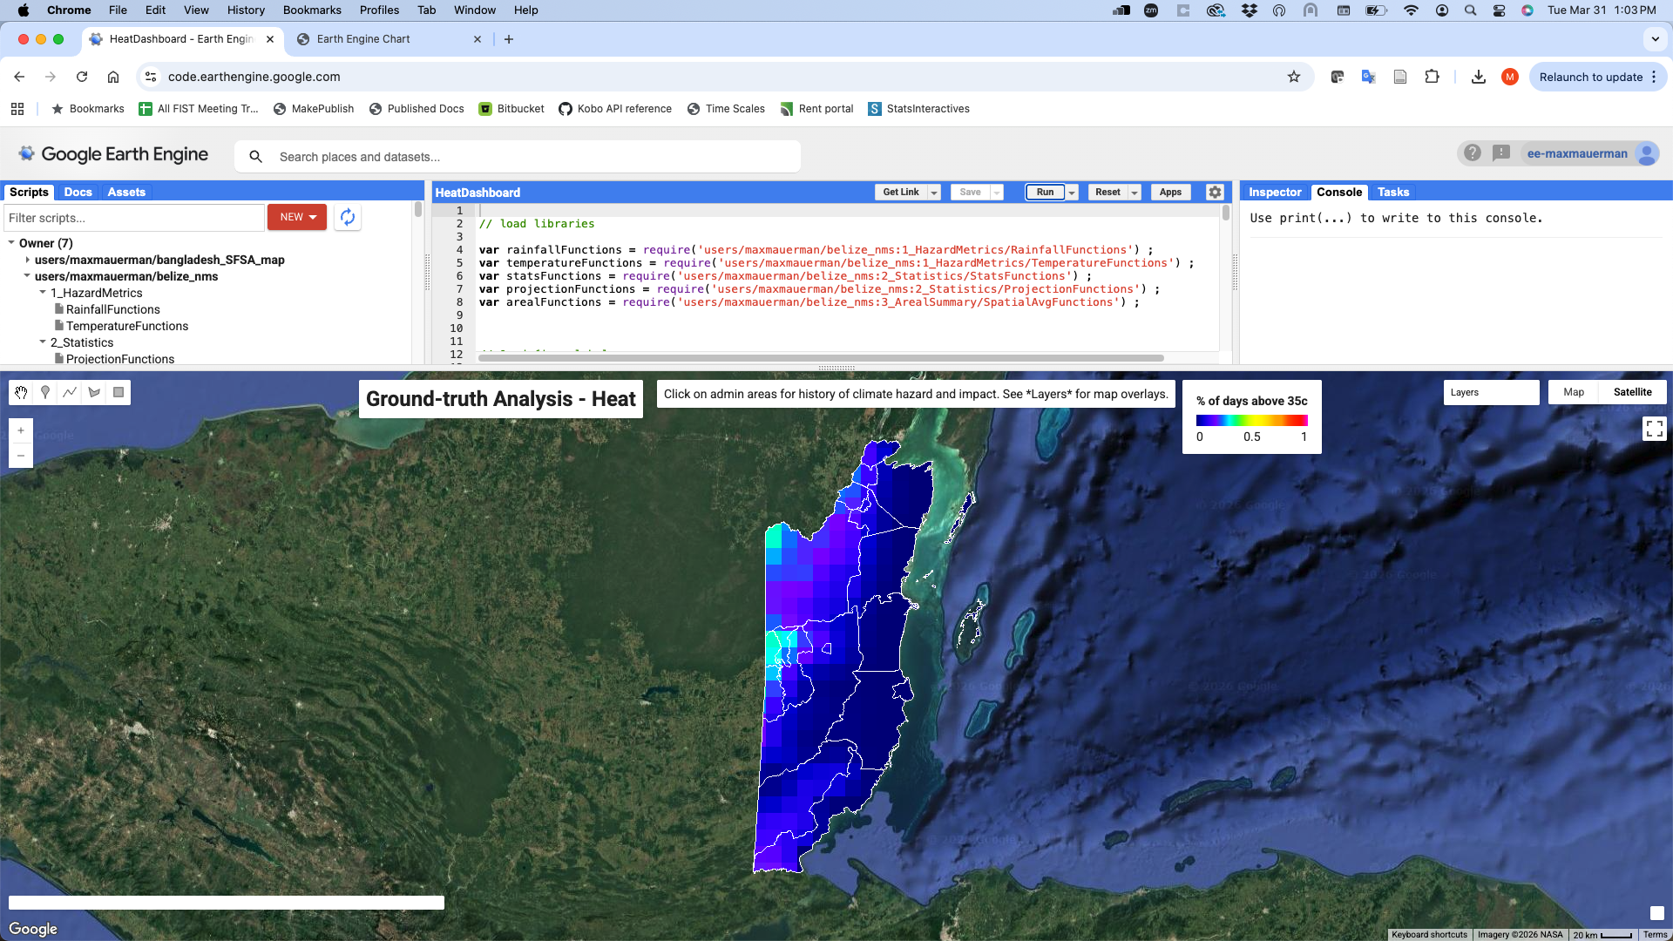



This map shows the average percentage of days in the year above 35c, 2010-present.

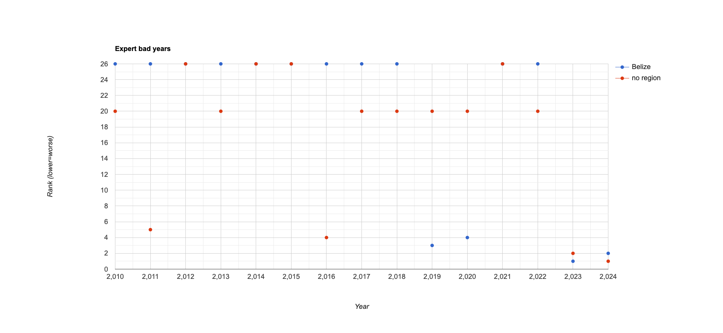
This plot shows the reported worst years for heat impact in Belize, based on stakeholder feedback.

Orange Walk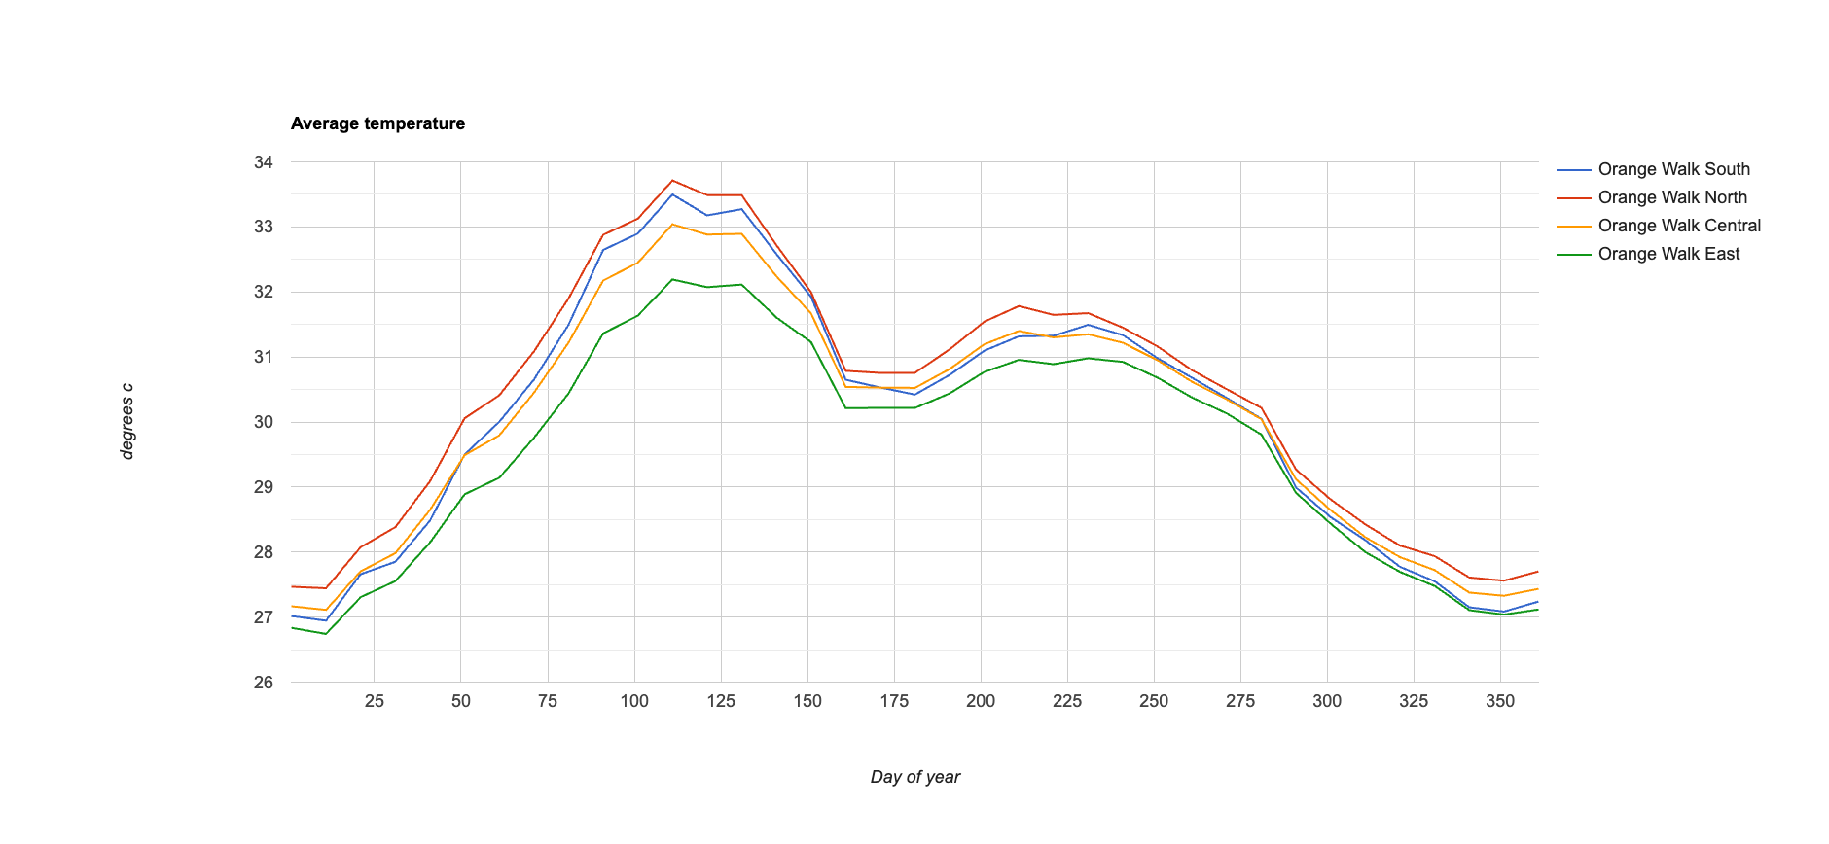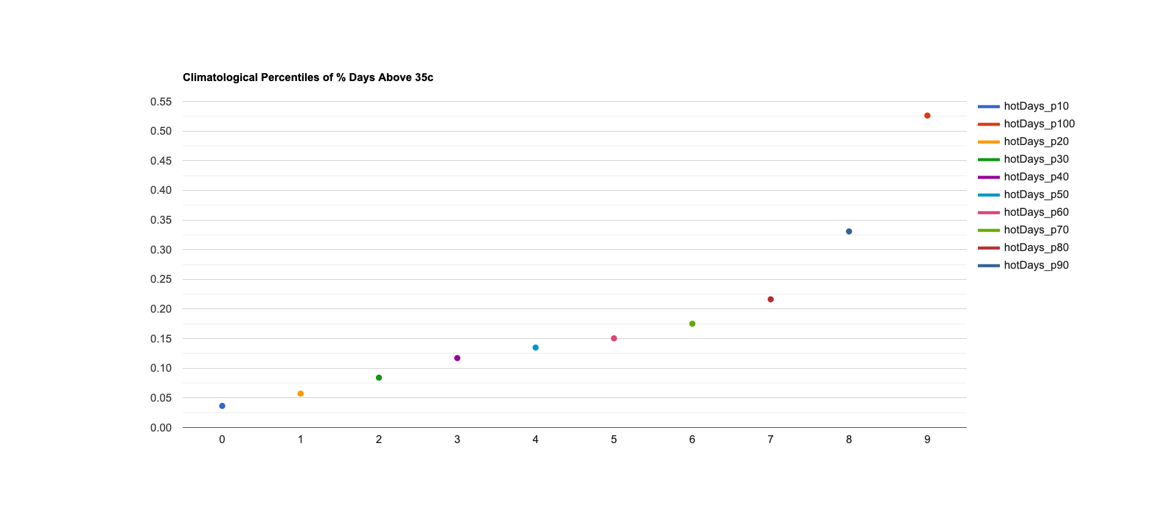
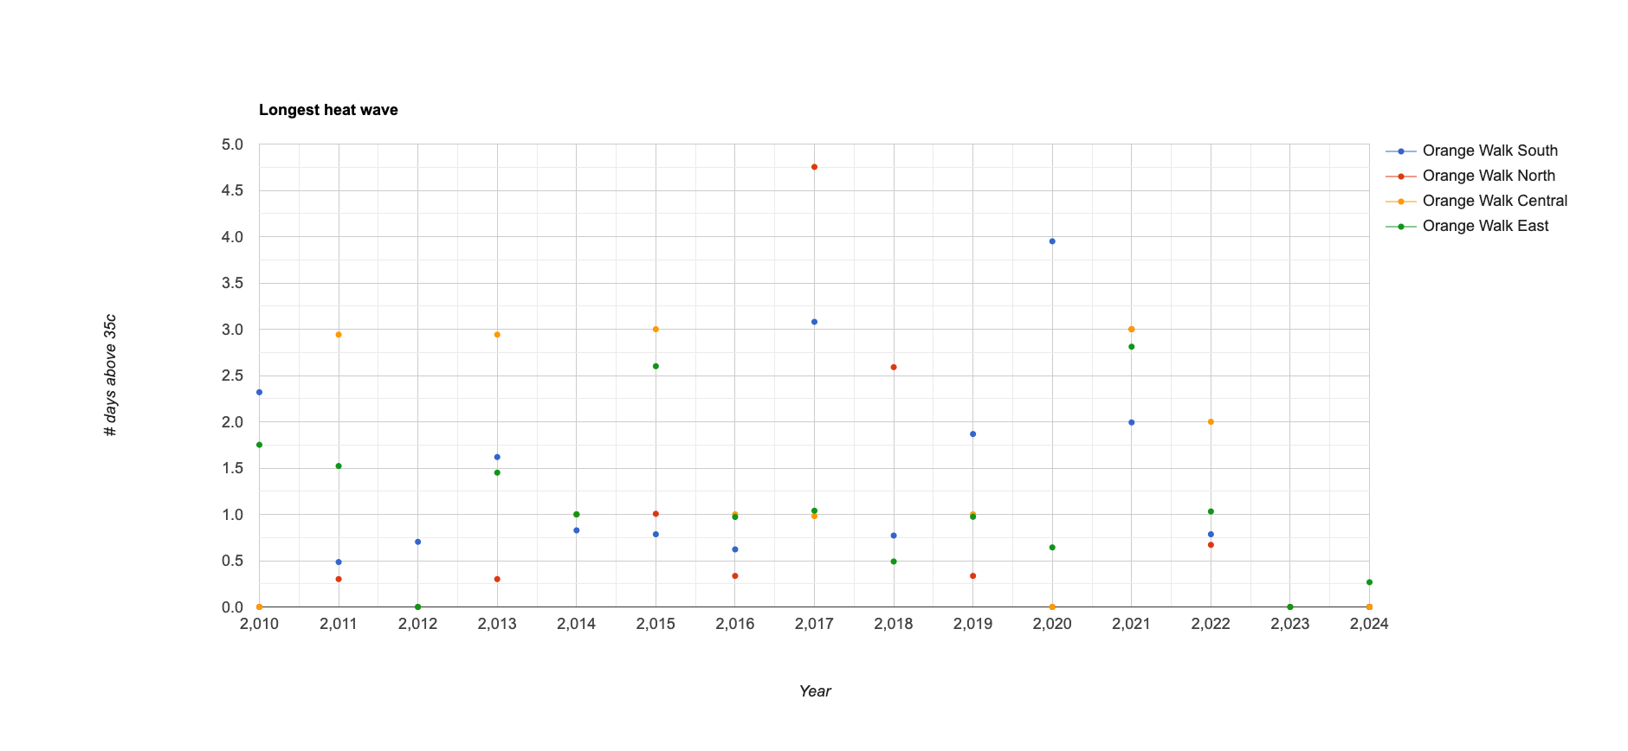

These plots show the rainfall climatology, historical heat waves, and percentiles of days above 35c for the constituencies of Orange Walk District. Some of the worst years in terms of heat waves were 2022, 2021, 2020, 2019, 2018, 2017, 2015, 2013 and 2011, although there was some variation across constituencies. Of those years, 4 were mentioned as impactful heat waves by stakeholders.

Toledo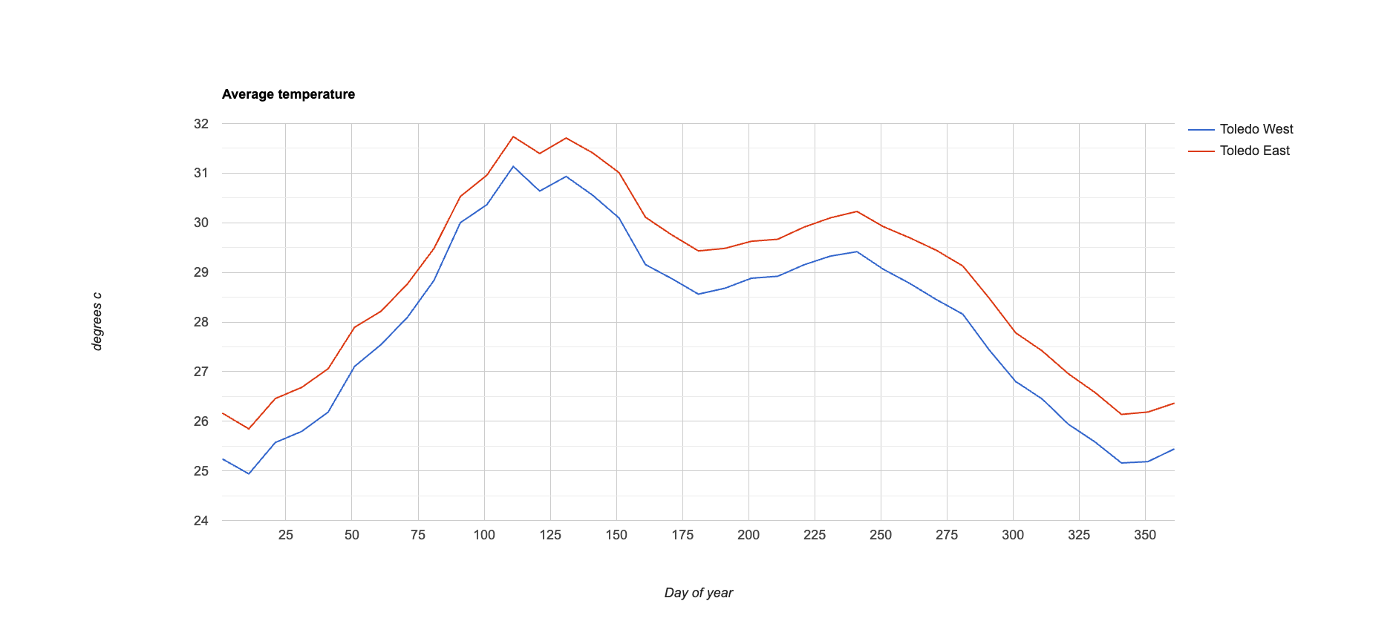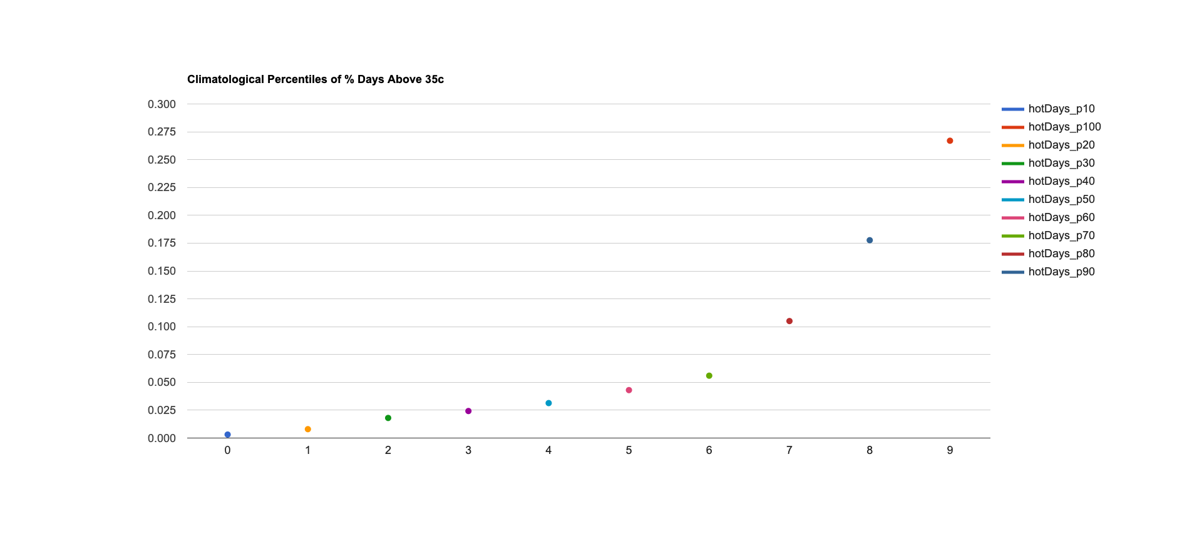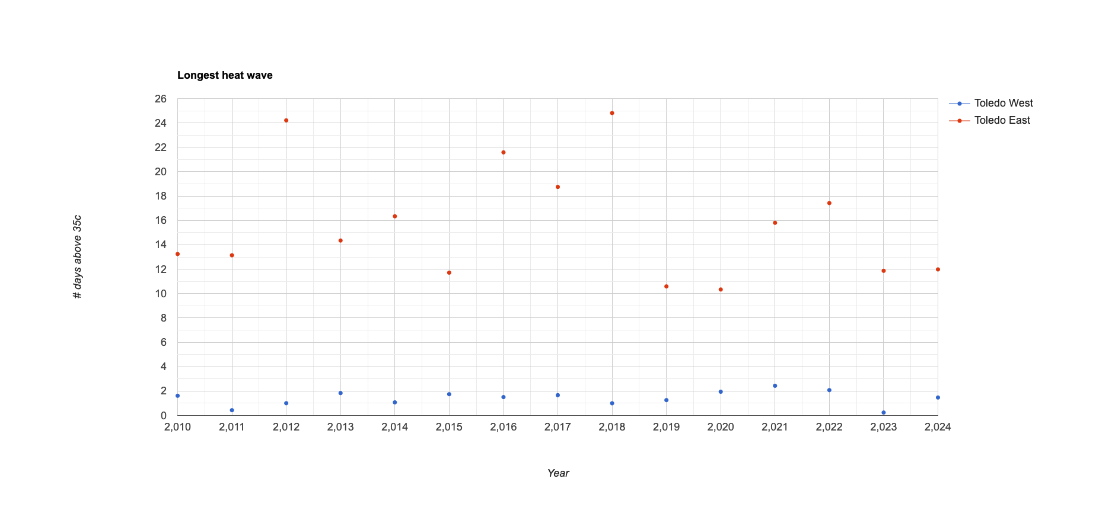
These plots show the rainfall climatology, historical heat waves, and percentiles of days above 35c for the constituencies of Toledo District. Some of the worst years in terms of heat waves were 2022, 2021, 2018, 2017, 2016, 2014, 2013 and 2012, although we only see significant hazards in Toledo East. Of those years, 3 were mentioned as impactful heat waves by stakeholders.

Station Analysis
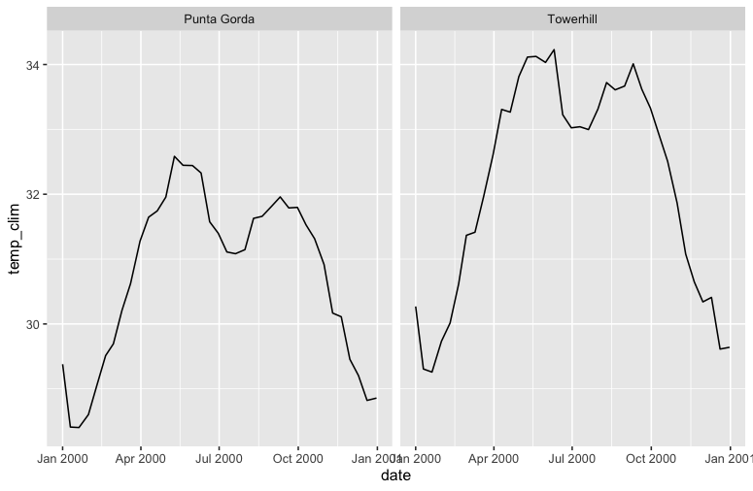
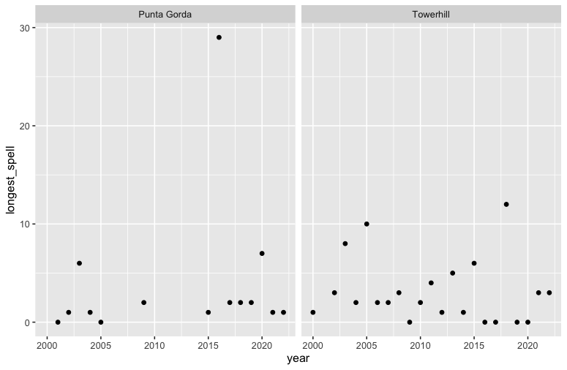
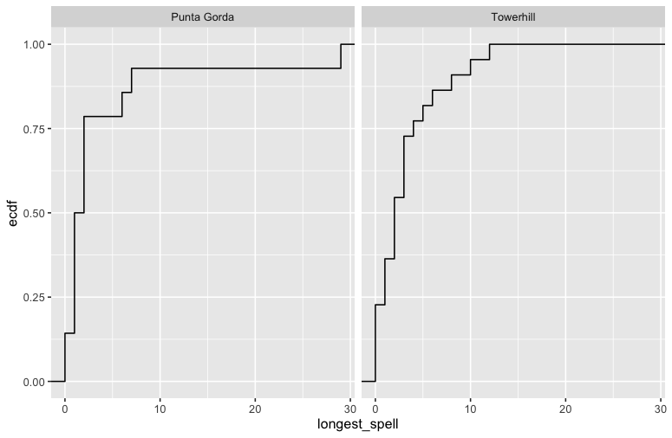

The above plots show the same analysis quantities, but computed with NMS weather station data instead of CHIRPS.

Storms
https://ee-maxmauerman.projects.earthengine.app/view/belizestorms

For the analysis of tropical storms, we used data on storm path and intensity from the IBTRaCS dataset to measure hazard. Storms are coded in the dataset as follows:

-5: Unknown [XX]
-4: Post-tropical [EX, ET, PT]
-3: Miscellaneous disturbances [WV, LO, DB, DS, IN, MD]
-2: Subtropical [SS, SD]
Tropical systems classified based on wind speeds [TD, TS, HU, TY,, TC, ST, HR] Values:

-1: Tropical depression (W<34)
0: Tropical storm [34<W<64]
1: Category 1 [64<=W<83]
2: Category 2 [83<=W<96]
3: Category 3 [96<=W<113]
4: Category 4 [113<=W<137]
5: Category 5 [W >= 137]

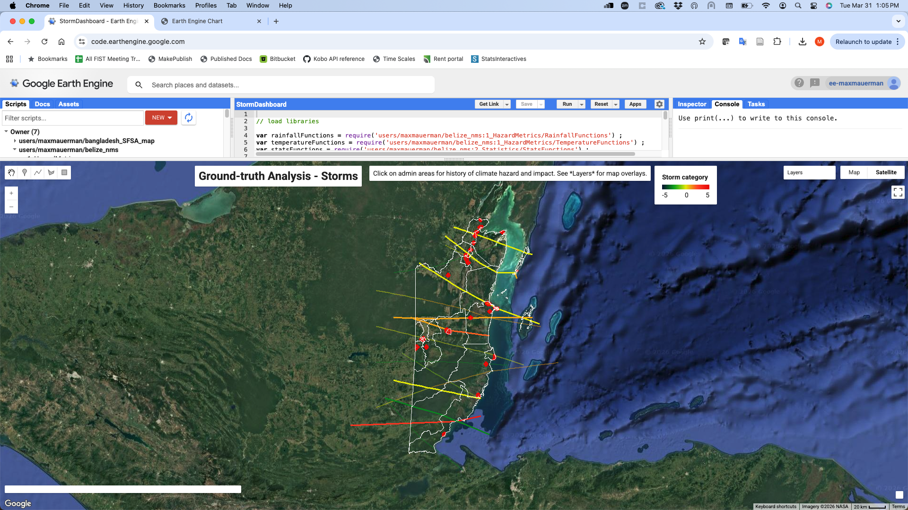



This map shows the paths of historical storms in Belize, 2000-present, with the storms mentioned by stakeholders as the most impactful highlighted in a different color. The most impactful storms tend to be of higher intensity category, but not exclusively. The most impactful storms tended to deviate from the usual storm paths in Belize, and intersected populated areas (the red dots on the map).

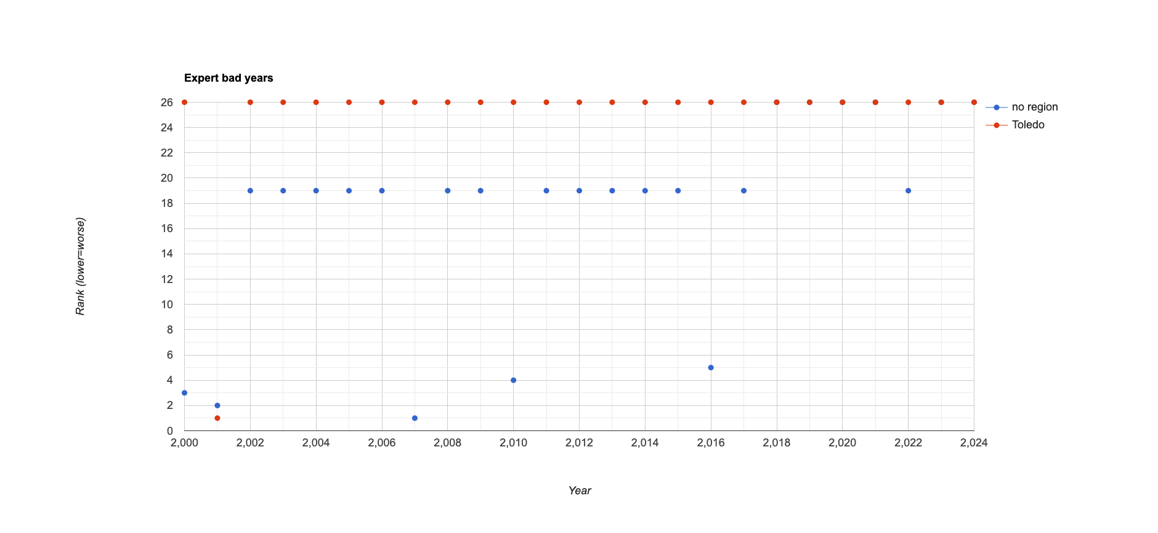
This plot shows the reported worst years for storm impact in Belize, based on stakeholder feedback.

Orange Walk

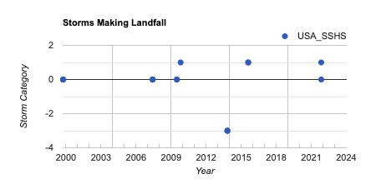
Years in which storms made landfall in Orange Walk district include the above.

Toledo
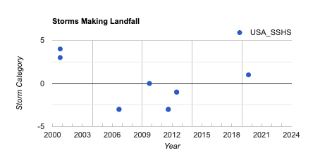
Years in which storms made landfall in Toledo district include the above.

Wildfires
https://ee-maxmauerman.projects.earthengine.app/view/belizewildfires

Based on feedback from NMS and stakeholders, we use two datasets to measure wildfires - one, the CEMS wildfire hazard index, combines moisture, heat and wind factors into a single index of wildfire propensity. The second, the Global Fire Atlas, records the extent and duration of historically observed wildfires.

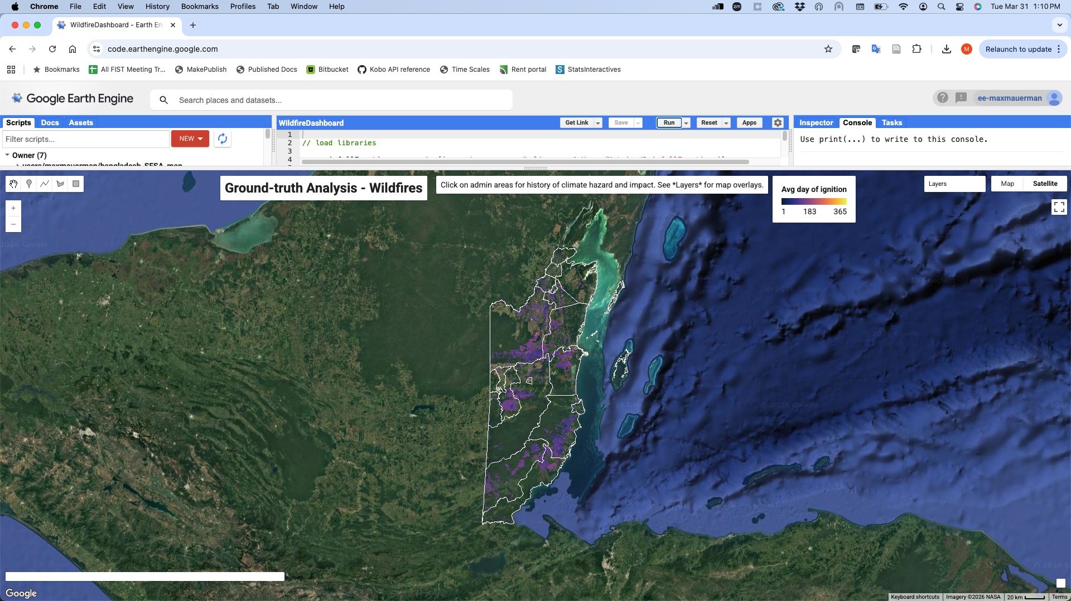


This map shows the average footprint of wildfires in the Global Fire Atlas, 2003-2016, colored by the average day of fire ignition.

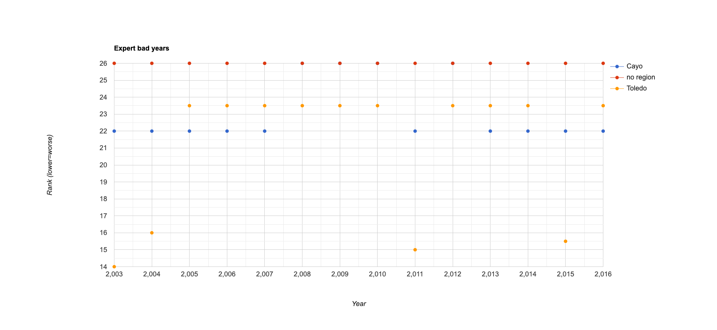
This plot shows the reported worst years for wildfire impact in Belize, based on stakeholder feedback.

Orange Walk
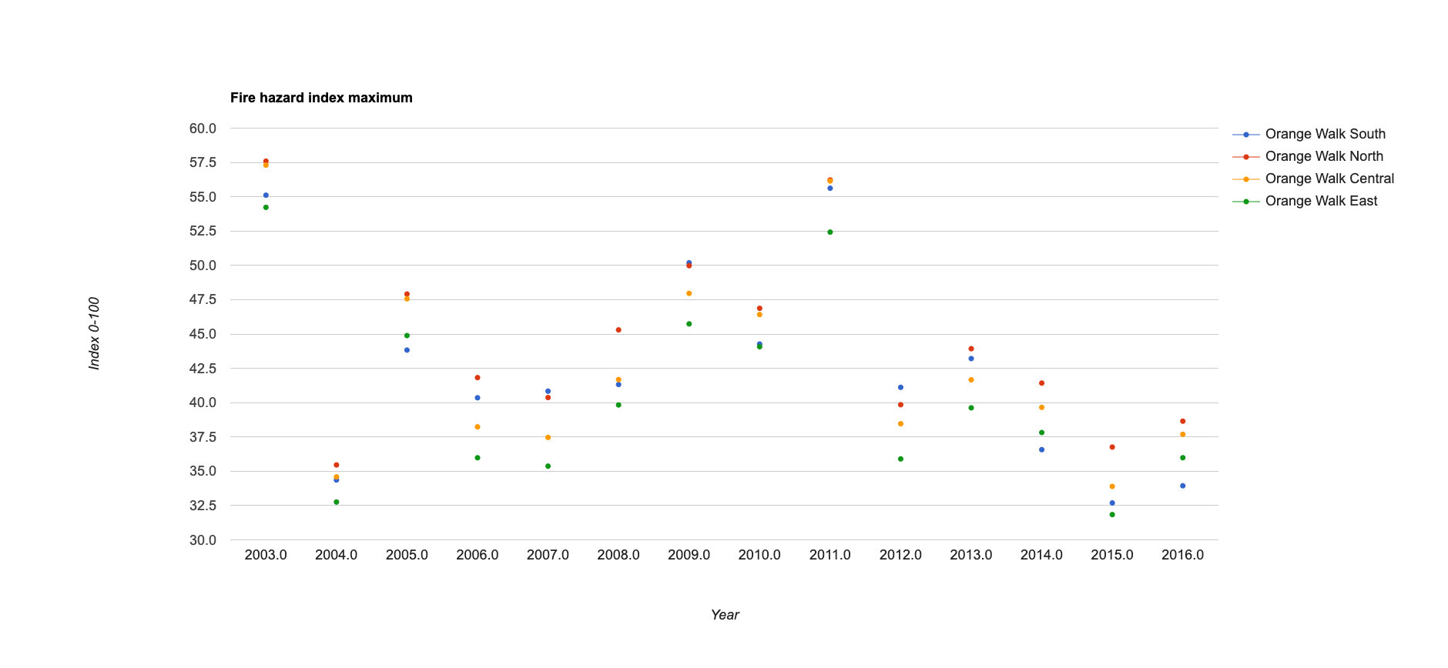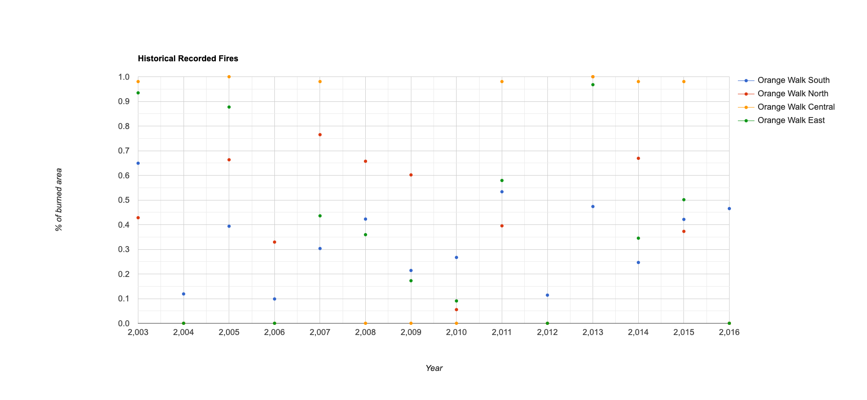
These plots show the wildfire hazard index and estimated extent of burned area for each constituency in Orange Walk District. Some of the worst years in terms of fire hazard include 2003, 2005, 2008, 2009, 2010, and 2011. Most of those years were associated with a large observed burned area. Most were also associated with reported stakeholder impacts, except for 2015, which did not score high on the fire hazard index despite large observed impacts.

Toledo
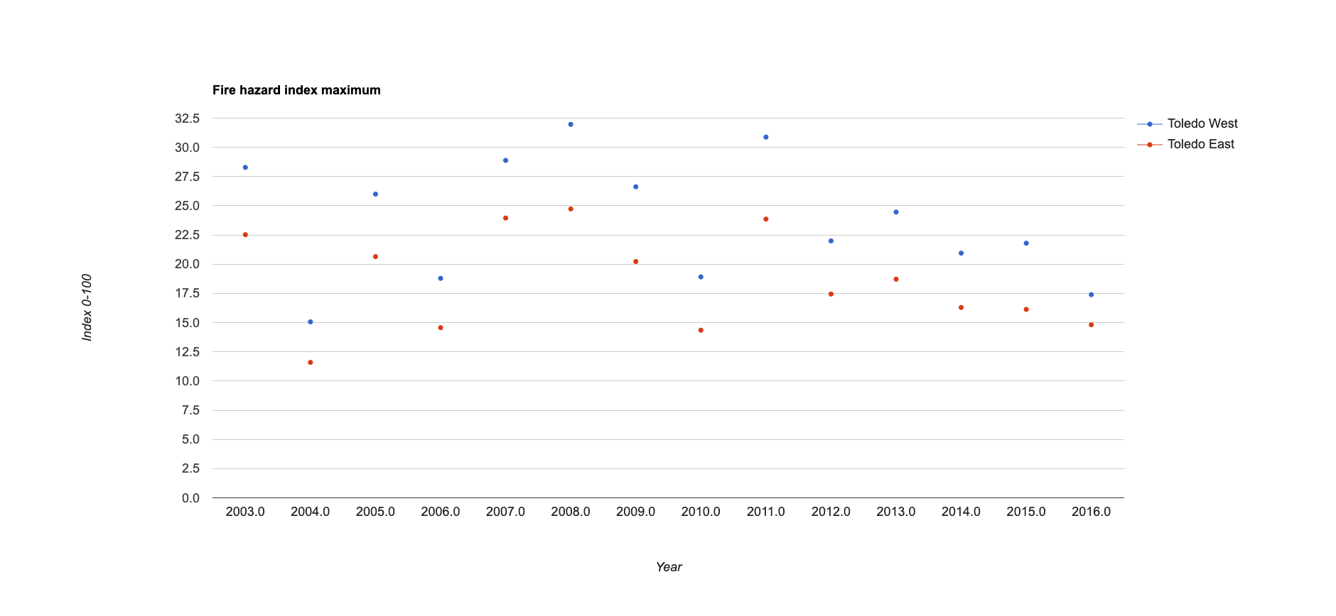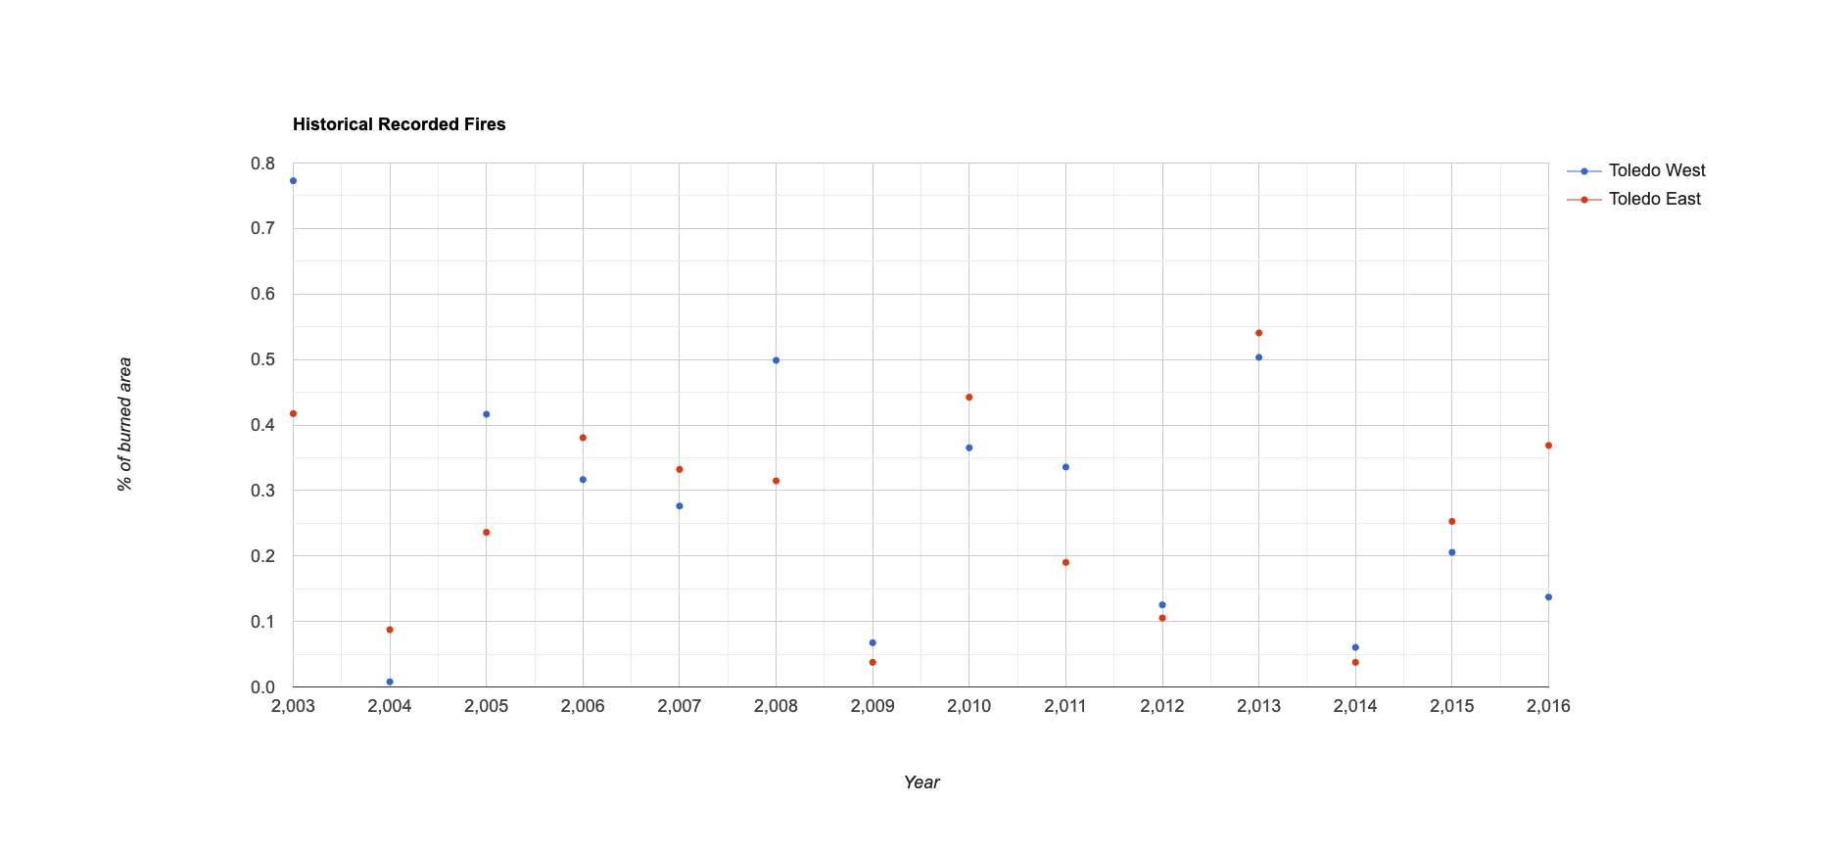
These plots show the wildfire hazard index and estimated extent of burned area for each constituency in Toledo District. Some of the worst years in terms of fire hazard include 2003, 2005, 2007, 2008, 2009, 2011 and 2013. Most of those years were associated with a large observed burned area. Most were also associated with reported stakeholder impacts, except for 2015, which did not score high on the fire hazard index despite large observed impacts.

Best Practices for Measurement and Forecasting

Early Warning System Design

Drought (Agricultural)
https://ee-maxmauerman.projects.earthengine.app/view/belizeonsetmonitor

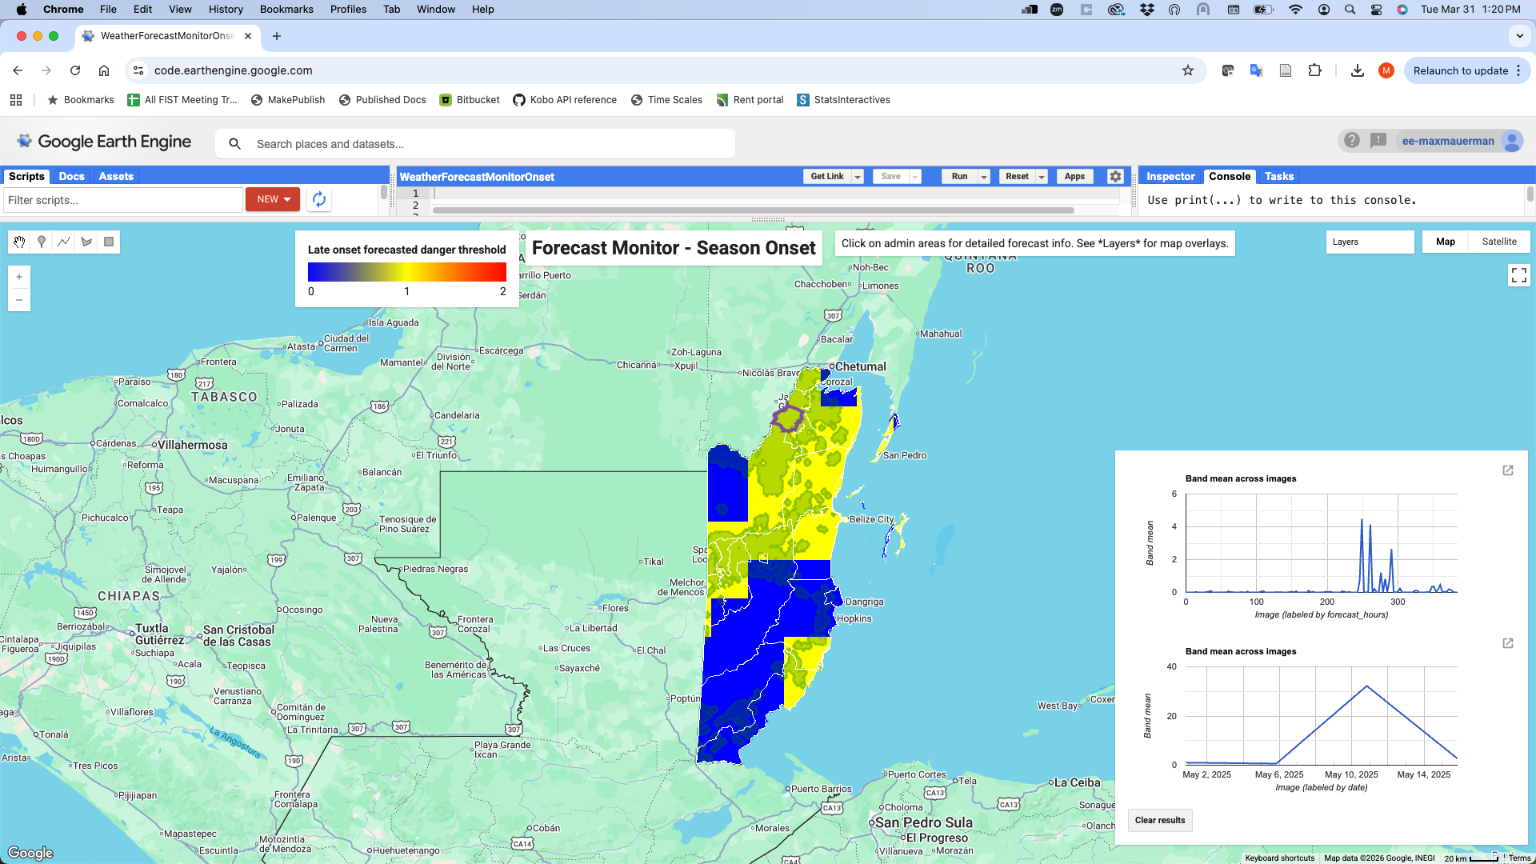

Incorporating metrics and danger thresholds from the stakeholder-driven hazard analysis, this maptool presents real-time impact-based forecast monitoring for rainfall onset in Belize. It can use either the GFS or ECMWF 15-day forecast products, aligning with what NMS uses. Areas are colored by whether they exceed a user-selected danger threshold - blue means it does not exceed the threshold, red means the season started late, and yellow means the season has not started yet.

Drought (Hydrological)
https://ee-maxmauerman.projects.earthengine.app/view/belizemonitor

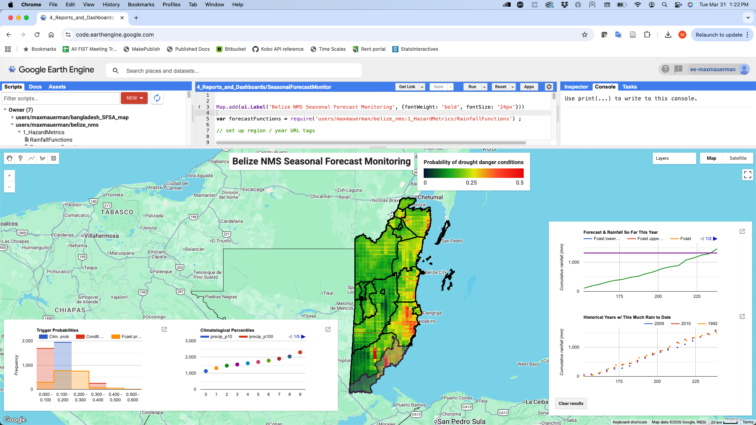

Incorporating metrics and danger thresholds from the stakeholder-driven analysis, this maptools presents monitoring of probabilistic seasonal forecasts against observed rainfall in Belize. It uses a tailored, downscaled regional forecast developed by WFP consultant Diego Pons (see “Supporting Literature” for details). In addition to incorporating forecast uncertainty, this maptool can show how the forecast in a season compares against observed rainfall thus far, and how similar historical seasons have ended.

Excess Rain
https://ee-maxmauerman.projects.earthengine.app/view/belizeexcessmonitor

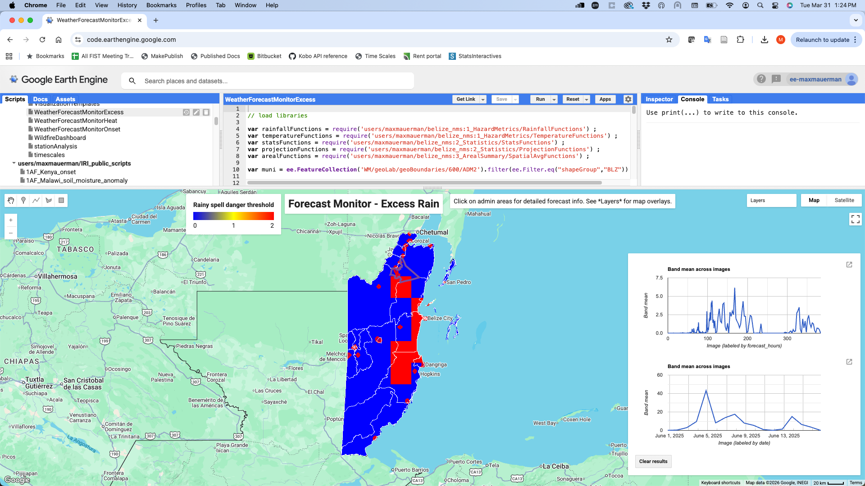

Incorporating metrics and danger thresholds from the stakeholder-driven hazard analysis, this maptool presents real-time impact-based forecast monitoring for excess rain spells in Belize. It can use either the GFS or ECMWF 15-day forecast products, aligning with what NMS uses. Areas are colored by whether they exceed a user-selected danger threshold.

Heat
https://ee-maxmauerman.projects.earthengine.app/view/belizeheatmonitor

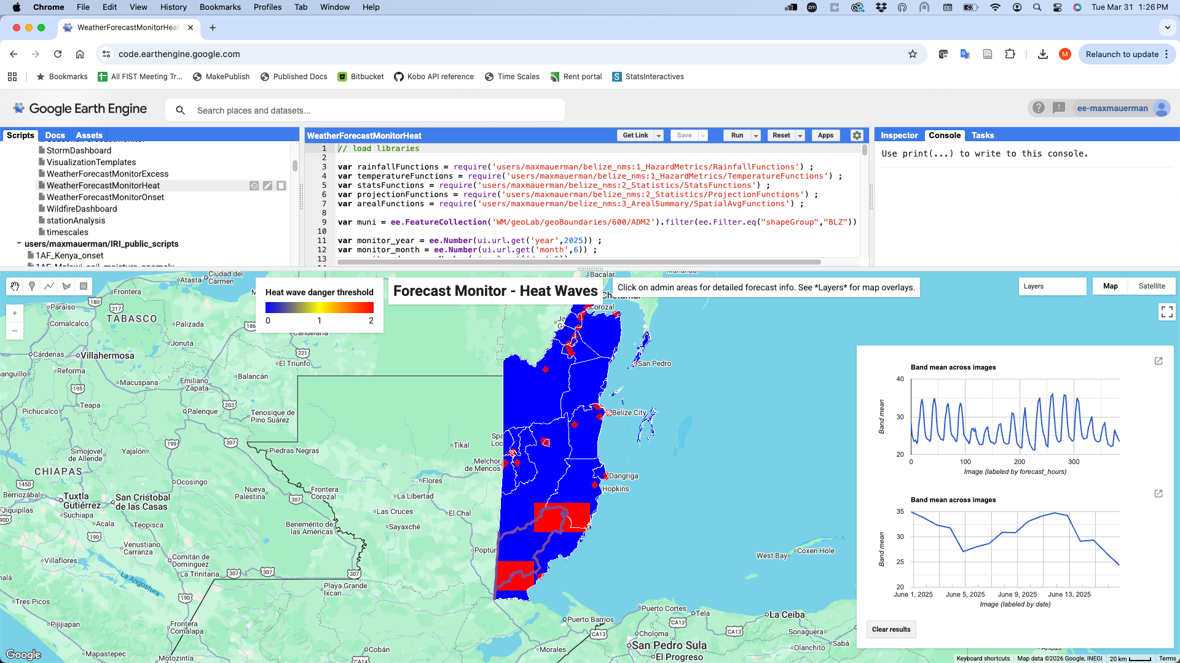

Incorporating metrics and danger thresholds from the stakeholder-driven hazard analysis, this maptool presents real-time impact-based forecast monitoring for heat waves in Belize. It can use either the GFS or ECMWF 15-day forecast products, aligning with what NMS uses. Areas are colored by whether they exceed a user-selected danger threshold.

Storms
https://www.nhc.noaa.gov/gis/

There is not currently a real-time storm track forecast product available via Google Earth Engine. However, the NOAA NHC forecast that NMS currently relies on is available as downloadable shapefiles, and these shapefiles could be overlaid on Google Earth Engine maps if desired. NMS staff have been capacitated on how to do this.

In terms of forecasting best practices, the most impactful storms in Belize appear to have been the ones that deviated from typical storm paths and / or intersected populated areas, so focusing on storm direction in context and not only intensity would be valuable for communicating forecasts in an impact-based way.

Wildfires
https://support.climateengine.org/article/49-cems-fire

We use the CEMS fire hazard index product (described above) as our main metric for wildfire hazard in Belize. A forecast version of this product does not exist, but the observational version is available in near-real time (updated monthly) and could be used as a monitoring measure of wildfire propensity. Our analysis found that this index was strongly predictive of stakeholders’ most impactful wildfire events.

Supporting Literature

Our choices of which climate data and forecast products to use were supported by the following scientific literature:

On CHIRPS accuracy in Belize:

https://agupubs.onlinelibrary.wiley.com/doi/full/10.1029/2025EA004720

On weather forecast skill in Belize:

https://link-springer-com.ezproxy.cul.columbia.edu/article/10.1007/s00382-018-4234-z

On seasonal forecast skill in Belize:

https://www-sciencedirect-com.ezproxy.cul.columbia.edu/science/article/pii/S2405880722000279

Skill map for Diego Pons’ downscaled regional seasonal forecast, covering Belize:

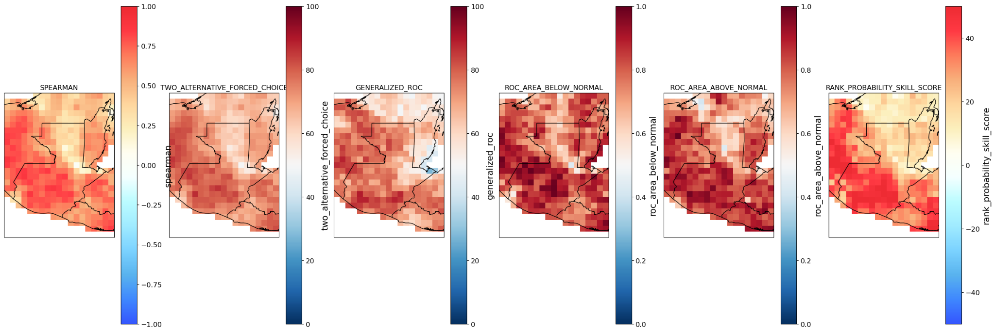

Key Early Warning Messages

The following sections summarize stakeholders’ feedback on how their key forecast-dependent actions, the information they would like to communicate to constituents, and the information they would like to know from community members.

Forecast-based actions

Hazard | Organization | Action type | Action description
Drought | Hydro Belize Limited | Severe | Communicated forecast to downstream stakeholders
 |  |  | Apply more stringent dispatching in power generation
 |  |  | Plan shift in annual maintenance program to better manage water storage.
 |  |  | Coordinate with BEL to ensure availability durning peak periods
 |  |  | Ensure at least 1.5 m3 flow downstream from the Vaca plant.
 |  | Moderate | Coordinate with BEL to shift dispatching practices to conserve water for drought period
 |  |  | Communicate forecast to downstream stakeholders
 |  |  | Ensure environmental flow downstream. 1.5 m3
Flood / Excess Rainfall | Red Cross | Severe | Evacuation of communities
 |  |  | Prepositioning of Livestock and Preharvest and storage
 |  |  | Preparation of shelters
 |  |  | Resource Mobilization- release of funds for relief
 |  |  | Securing Food and relief packages
 |  | Moderate | Transportation Plan - alternatives
 |  |  | Preparation of Relief packages
Extreme Heat | Ministry of Education Science and Technology | Severe | Revisit the time schools open and close.
 |  |  | Infrastructural changes, ventilation, central air
 |  |  | (close the classroom etc.)
 |  |  | Students attire on hot days
 |  | Moderate | Activate school heat preparedness protocols
 |  |  | Inform principals and teachers through official circulars
 |  |  | Review students schedule
Storms | Ministry of Blue Economy and Marine Conservartion, TASA, UNDP, Ministry of Human Development, 5C's, NMS, Digicell | Severe | Disperse funds to potential risk areas
 |  |  | Secure government assets, and public utilities and energy to maintain resources after the storm. Secure generators and fuel sources.
 |  |  | Mobilize emergency response teams and prepare evacuation routes and designated shelters
 |  |  | Relocation of humans and animals
 |  |  | Suspend high risk field activities including fishing and ecotourism
Wildfires | National Biodiversity Office | Severe | Man Made pond ecosystems (To counter fires)
 |  |  | Manpower (Employment of environmental Firefighters etc)
 |  |  | Restoring Wetlands (restoring waterbodies)
 |  |  | Restoring of damaged ecosystems with a new type of vegetation.
 |  |  | Technology(Moniter fire)
 |  | Moderate | Public education (Courses for immediate communities, Fire training)
 |  |  | Moderate Patrolling (Rangers)
 |  |  | Restore wetlands
 | Denham Chuc | Severe | Mass Advisory alerts-
 |  |  | Do fire lines
 |  |  | disallow all fire permits
 |  |  | EXECUTE information campaign
 |  |  | Identify viable water sources to be prepared in the event of outbreak
 |  | Moderate | maintain fire pass and breaks
 |  |  | remove excess fuel load
 |  |  | EXECUTE information campaign

Forecast / climate information needed
Hazard | Organization | Information Type | Answer
Drought | Hydro Belize Limited | What info needed | At least 6 month advanced forecast.
 |  | Lead time of info | 6 months
 |  | Who needs info | VP of Operations. In excel format with graphic trends.
Flood / Excess Rainfall | Red Cross | What info needed | Area of Impact, speed of onset and duration before water recedes
 |  | Lead time of info | More than 3 days , preferably 7 days
 |  | Who needs info | Director General
Extreme Heat | Ministry of Education Science and Technology | What info needed | preliminary information on heatwaves that would affect teacher, learners, stakeholders in Education.
 |  | Lead time of info | Beginning of the school year.
 |  | Who needs info | Senior Management Team in the Ministry of Education
Storms | Ministry of Blue Economy and Marine Conservartion, TASA, UNDP, Ministry of Human Development, 5C's, NMS, Digicell | What info needed | localized forecast for Toledo, areas prone to storm surge, expected rainfall and flood prone areas, maximum wind speed expected
 |  | Lead time of info | minimum 3 days and maximum 7 days in advance for preparedness planning
 |  | Who needs info | When NEMO is activated to government is activated.
Wildfires | National Biodiversity Office | What info needed | Drought Occurances (When ecosystem are dry) , Vegetation Types (So we can locate potential high risk areas)
 |  | Lead time of info | The earlier the information is provided, the more helpful it would be to make informed decisions
 |  | Who needs info | Meterology Office/ Department of the Environment / National Biodiversity Office /National Climate change office
 | Denham Chuc | What info needed | Wind Speed and direction -Temperature - drought warnings- fuel load- Humidity-visibility
 |  | Lead time of info | 3 months in advance
 |  | Who needs info | Forest Department - NEMO- MET- Co management agencies- BTB-BTIA- Format by email and WhatsApp

Questions for the community

Hazard | Organization | Questions
Drought | SIRDI | If they have experienced any impact on crop yields, heat stress.
 | Belize Telecommunication Limited | During which months do you normally experience the most water shortages?
 | Sugar Industry Research & Development Institute | Have you changed your replanting season
 | Hydro Belize Limited | How has drought been impacting the agricultural sector and what mitigation plans are in place.
 | SIRDI | How it affected their livelihoods(% decrease in income. % loss to production ect). Are you technical and financially prepared? If no what support, you required and who should lead. Where do you get information about weather forecasts or climate change?
 | Hydro Belize Limited | What period of the year can HBL best support your sector with increased water flow on the Macal River
Extreme Heat | Ministry of Economic Transformation | Inquire what their knowledge and what actions contribute or mitigate climate impacts
 | Ministry of Education Science and Technology | Heat affects all regions in Belize's Educational Landscape, hence the above mentioned is applicable to all regions.
Flood / Excess Rainfall | Belize Red Cross Society | general impacts and extent of disruptions in their daily lives, and severity.
 | Red Cross | How was your household affected by floodings? not only economic but social
Storms | Ministry of Blue Economy and Marine Conservation | What is the cost of damages caused by climate impacts?
 | Ministry of Blue Economy and Marine Conservartion, TASA, UNDP, Ministry of Human Development, 5C's, NMS, Digicell | In your lifetime have you seen this level of destruction before. What is the cost associated with the damage? What is your preferred medium of communication during a disaster?
Wildfires | Belize Forest Department | Weather Conditions
 | Ministry of Agriculture | How has wildfires affect your quality of life?
 | National Biodiversity Office | How has Forest Fires affected you ? Elaborate on a extreme forest fire that has plagued the community, and in what way ?
 | Denham Chuc | last 10 years, have you had increase fires, floods or change in coastline or changes that affected living conditions

Potential Next Steps

Policy next steps
- Community outreach - The Belize Red Cross and Ministry of Agriculture expressed interest in applying the bad year crowdsourcing methodology with rural community members, in addition to stakeholders. We shared a survey protocol designed for farmers with them, and further integration of community perspectives could be a topic for future work.
- Extension to more hazards, sectors, districts - This project focused on the Orange Walk and Toledo districts, but a similar approach could be scaled up to further location- or sector-specific analysis.
- Extension to other Caribbean countries - The Caribbean Climate Change Community Center expressed interest in scaling up this project’s approach to other countries in the region.
- Tailored text alerts and two-way communication - We have developed open-source tools for two-way text interactions via Whatsapp, which we are deploying or have deployed in Colombia, Guatemala and the United States. These tools could be used not only to distribute tailored early warning information to communities, but also collect crucial information from communities about the factors affecting their vulnerability and preparedness.

Technical next steps
- Google Earth Engine data pipeline for NMS weather station data - We explored the possibility of integrating NMS’s station data directly into Google Earth Engine, but making this operationally available would require some additional technical effort.
- Stakeholder shapefiles - If stakeholders have shapefiles of schools, health facilities, etc. that they would like to be reflected in the hazard and forecast map rooms, these could be added.
- Institutional Google Earth Engine licensing - We could look into the necessary steps for NMS to acquire an institution-wide license for Google Earth Engine noncommercial use, which would expand their potential use of the technology.

